

Bay Area Clean Water Agencies
Draft 2016 Biosolids Trends Survey Report

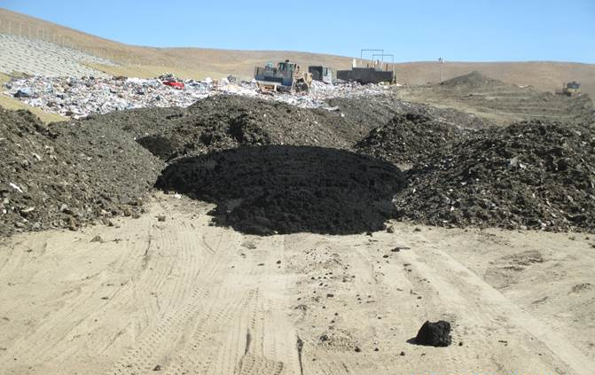
Photo: Biosolids incorporation as Alternative Daily Cover at a landfill

Contents
1. Introduction 3
2. Annual Biosolids Production 5
3. Management Options, Management Costs and Dewatering Statistics 7
3.1 Biosolids Reuse and Disposals Options 7
3.2 Management Costs 13
3.3 Hauling Distance 16
3.4 Dewatering Statistics 17
4. Challenges and Future Planning 19
4.1 Challenges 19
4.2 Future Biosolids Management Plans 19
5. Public Outreach 23
5.1 Marketing 23
5.2 Outreach and Education 23
6. Biosolids Staff 23
7. Future surveys 25
APPENDIX A – AGENCY DATA: 2015 Reuse and Disposal Alternatives 26

Introduction
Biosolids management programs at Publically Owned Treatment Works (POTWs) are under increasing pressure in the San Francisco Bay Region. Northern California POTWs are much more likely to use landfill Alternative Daily Cover (ADC) as a reuse strategy than their counterparts in Southern California. However, new legislation and regulation aimed at diverting organic material from landfills is making it increasingly likely that landfill burial and ADC will be phased out in the future. The California Association of Sanitation Agencies (CASA) prepared An Evaluation of the Sustainability of Biosolids Use as Landfill Burial or Beneficial Cover Material, which is an excellent summary of the regulatory challenges facing biosolids reuse and management alternatives for California agencies.

Bay Area Clean Water Agencies (BACWA) is a joint powers agency whose members own and operate publicly-owned treatment works (POTWs) and sanitary sewer systems that collectively provide sanitary services to over 7.1 million people in the nine-county San Francisco Bay Area (Bay Area). BACWA supports a Biosolids Committee, where members can meet to discuss common issues, and tour local biosolids facilities. Staff from agencies outside the San Francisco Bay Region may participate in BACWA’s Biosolids Committee.

In 2016, BACWA distributed a survey to its member agencies to better understand the state of the biosolids treatment, disposal and reuse in the Bay Area. The intent of this survey was to summarize information obtained from BACWA members in order to identify current industry trends for the following issues:

- Biosolids production
- Hauling and tipping costs
- Hauling distances
- Dewatering technologies
- Agency challenges
- Agencies future biosolids management plans
- Marketing and media practices
- Biosolids program staffing

The Survey includes responses from the following agencies, representing more than 95 percent of the total flow of BACWA member agencies, plus the City of Santa Rosa which is not a BACWA member:

- Central Contra Costa Sanitary District
- Central Marin Sanitation Agency
- City of American Canyon
- City of Benicia
- City of Hayward
- City of Livermore
- City of Millbrae
- City of Palo Alto
- City of Petaluma
- City of San Jose
- City of San Leandro
- City of San Mateo
- City of Santa Rosa
- City of South San Francisco - San Bruno Water Quality Control Plant
- City of Sunnyvale
- Delta Diablo
- Dublin San Ramon Services District
- East Bay Municipal Utility District
- Fairfield-Suisun Sewer District
- Las Gallinas Valley Sanitary District
- Mt. View Sanitary District
- Napa Sanitation District
- Novato Sanitary District
- Oro Loma SD
- San Francisco Public Utilities Commission
- Sewer Authority Mid-Coastside
- Sewerage Agency of Southern Marin
- Silicon Valley Clean Water
- Union Sanitary District
- Vallejo Sanitation and Flood Control District
- West County Wastewater District

The survey data presented in this report will provide a baseline against which to compare data in future surveys. The body of the report summarizes the data provided by agencies, but the data on reuse and disposal destinations is presented in full in Appendix A.

It is BACWA’s intention to conduct this survey on a biennial basis. Agency responses will be used as part of a Regional conversation about the future of biosolids management in Northern California, to identify regional needs, and to support efforts to identify and develop additional sustainable biosolids reuse alternatives. The survey was modeled after the Southern California of Publicly Owned Treatment Works (SCAP) Biosolids Trends Survey and allows data comparisons between northern and southern California agencies.

BACWA wishes to thank all of our agencies that took the time and effort to assist with the production of this survey.
Inset 1: Anaerobic Digesters at SFPUC’s Oceanside Wastewater Treatment Plant
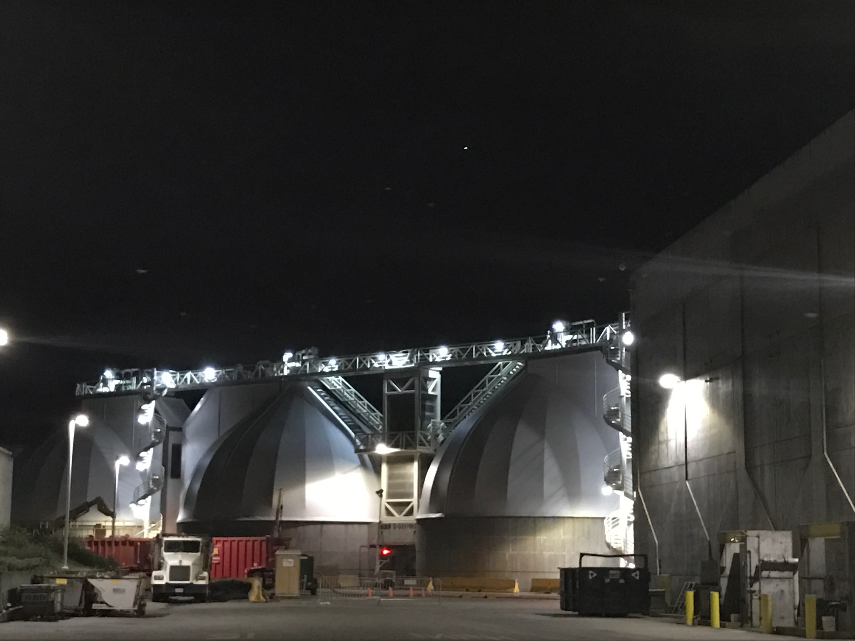

Annual Biosolids Production

Survey respondents reported their biosolids production for the 2014 and 2015 calendar years. Figure 1a and 1b compare the total tonnage of wet and dry tons, respectively, which were largely unchanged between the two calendar years. The preponderance of wet tons of biosolids produced in the San Francisco Bay Region are Class B, although the differential between Class A and B is smaller when considering dry tons since agencies producing Class A biosolids produce a higher percentage solids.

Figure 1a. Aggregate wet tons of biosolids of different classes produced by survey respondents.

Figure 1b. Aggregate dry tons of biosolids of different classes produced by survey respondents.

Management Options, Management Costs and Dewatering Statistics

3.1 Biosolids Reuse and Disposals Options
The amount of biosolids sent to each type of reuse and disposal destination by each responding agency is reported in Table 1. The accompanying Figure 2 illustrates the relative importance of each reuse and disposal method. Reuse via landfill alternative daily cover (ADC) receives the most tonnage of biosolids in the Region, followed by land application. Onsite disposal and incineration come next, followed distantly by landfill disposal and compost.

Inset 2: East Bay Municipal Utilities District Digesters
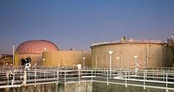

Table 1. Wet tons of biosolids delivered by usage, 2015.
 | Landfill | Landfill ADC | Land Application | Compost | Incineration | Onsite disposal | Total
Central Contra Costa Sanitary District |  |  |  |  | 72,297 |  | 72,297
Central Marin Sanitation Agency |  | 2,876 | 1,567 |  |  |  | 4,443
City of American Canyon |  | 197 |  |  |  |  | 197
City of Benicia |  | 2,330 |  |  |  |  | 2,330
City of Hayward | 2,396 |  |  |  |  |  | 2,396
City of Livermore |  | 5,751 | 2,060 |  |  |  | 7,811
City of Millbrae |  |  | 1,139 | 121 |  |  | 1,260
City of Palo Alto * |  |  |  |  | 6,936 |  | 6,936
City of Petaluma |  | 9,169 |  |  |  |  | 9,169
City of San Jose |  | 53,405 |  |  |  |  | 53,405
City of San Leandro |  |  | 7,590 |  |  |  | 7,590
City of San Mateo |  | 3,083 | 3,828 |  |  |  | 6,911
City of Santa Rosa |  | 2,349 | 21,656 | 8,514 |  |  | 32,519
City of South San Francisco - San Bruno Water Quality Control Plant | 13,981 |  |  |  |  |  | 13,981
City of Sunnyvale |  | 702 | 11,700 | 321 |  | 2,641 | 15,364
Delta Diablo |  | 1,119 | 10,800 | 114 |  |  | 12,033
Dublin San Ramon Services District |  |  |  |  |  | 37,500 | 37,500
East Bay Municipal Utilities District |  | 43,001 | 33,024 |  |  |  | 76,025
Fairfield-Suisun Sewer District |  | 11,219 |  |  |  |  | 11,219
Las Gallinas Valley Sanitary District |  |  |  |  |  | 4,170 | 4,170
Mt. View Sanitary District |  | 750 |  |  |  |  | 750
Napa Sanitation District |  |  |  |  |  | 66,362 | 66,362
Novato Sanitary District |  |  |  |  |  | 18,000 | 18,000
Oro Loma SD |  | 9,841 |  |  |  |  | 9,841
San Francisco Public Utilities Commission |  | 37,013 | 32,909 | 3,371 |  |  | 73,293
Sewer Authority Mid Coastside | 1,485 |  |  |  |  |  | 1,485
Sewerage Agency of Southern Marin |  | 722 | 260 |  |  |  | 982
Silicon Valley Clean Water |  | 5,045 | 13,313 | 2,981 |  |  | 21,339
Union Sanitary District |  | 2,450 | 13,313 | 3,470 |  |  | 19,233
Vallejo Sanitation and Flood Control District |  |  | 12,292 |  |  |  | 12,292
West County Wastewater District |  | 9,304 |  |  |  |  | 9,304
Sum | 17,862 | 200,326 | 165,451 | 18,892 | 79,233 | 128,673 | 610,437

Figure 2. Relative wet tonnage of biosolids per reuse and disposal method in 2015

Another way to measure the relative importance of reuse and disposal methods is by counting the number of agencies that employ each, as illustrated in Figure 3. As can be seen in Table 1, many agencies use more than one reuse or disposal alternative. Out of the thirty-one responding agencies, nineteen use landfill ADC as one of their reuse alternatives. Land application is the next most popular, followed by compost and onsite disposal. Landfill disposal is used by just three agencies. Incineration is used by two agencies, although one of these agencies, the City of Palo Alto, will be transitioning away from incineration by 2019.

Figure 3. Number of agencies out of thirty-one respondents applying biosolids reuse alternatives in 2015.

While compost is the third-most common reuse application as illustrated in Figure 3, it is fairly minor in terms of tonnage (only 3%, see Figure 2).. The relatively minor use of compost by Bay Area agencies is notable, since in SCAP’s 2016 Biosolids survey, they found that composting represented approximately half of the tonnage of biosolids reuse for Southern California agencies. While there are currently no agencies reporting use of “Other Products,” in 2016 several agencies will begin sending their solids to the new Lystek Facility, hosted by the Fairfield-Suisun Sewer District, which will be producing liquid fertilizer for agriculture (see Inset 1 on pg. 9).

Inset 3. Lystek and Fairfield-Suisun Sewer District partnered to develop a facility to receive biosolids and convert them to liquid fertilizer. The new facility came online in 2016.
LYSTEK LAND APPLICATION OF LIQUID BIOFERTILIZER, SOLANO COUNTY
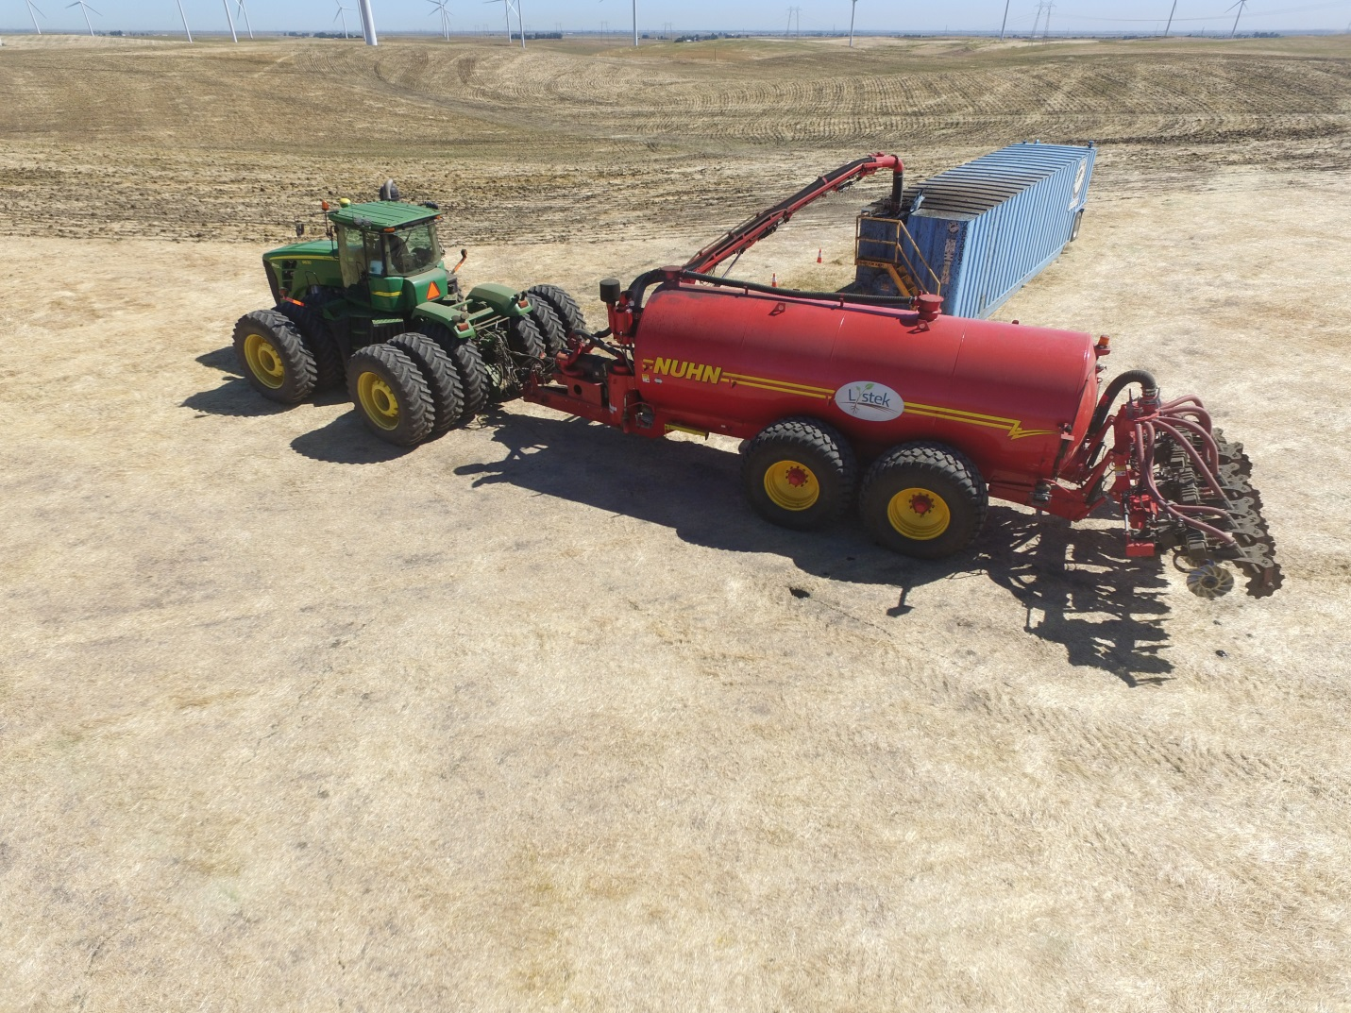
LYSTEK-FAIRFIELD ORGANIC MATERIAL RECOVERY CENTER, SOLANO COUNTY
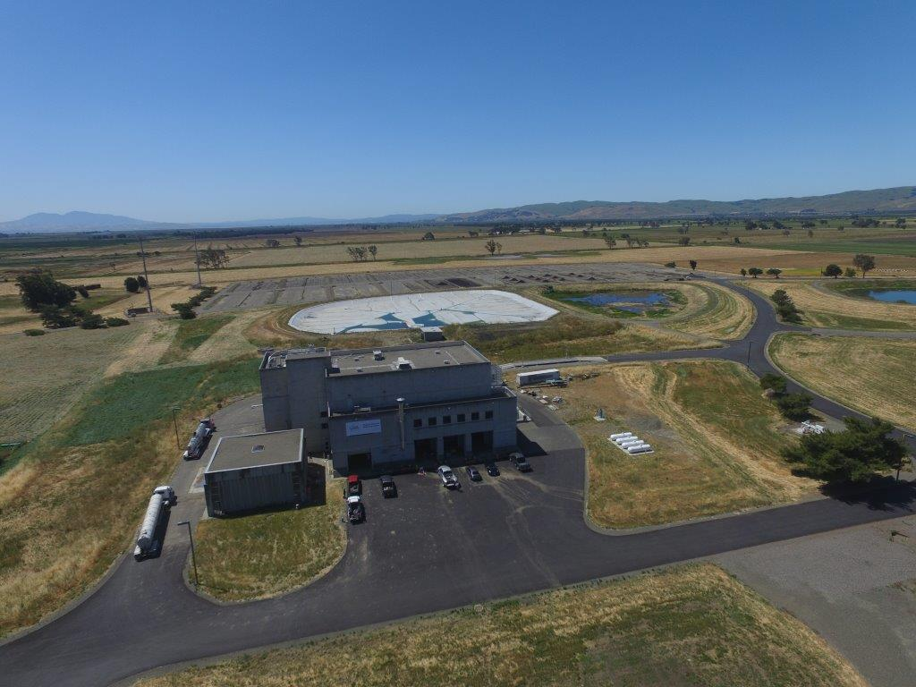

3.2 Management Costs
Agencies that send biosolids to multiple destinations report a range of costs per ton. Minimum and maximum reported hauling and tipping costs for each agency are reported in Table 2. Where costs were provided by the respondent as a range, the mean of the range was used for that destination. Total costs per agency are calculated by multiplying tons of solids by cost per ton for each destination and summing the destinations. Average costs for each agency are calculated by dividing total cost by tons of biosolids. In the future, cost trends will be tracked to see how they are changing over time.

Table 2: Hauling and tipping costs for agencies

 | Maximum cost/ton | Minimum cost/ton | Average Cost/ton | Total cost
Central Contra Costa Sanitary Districtª | $0.00 | $0.00 | $0.00 | $0
Central Marin Sanitation Agency | $23.58 | $89.50 | $43.59 | $193,663
City of American Canyon^{b} | $0.00 | $0.00 | $0.00 | $0
City of Benicia | $79.28 | $79.28 | $79.28 | $184,722
City of Hayward^{c} | not provided | not provided | not provided | not provided
City of Livermore | $40.00 | $40.00 | $40.00 | $312,440
City of Millbrae | $54.95 | $54.95 | $54.95 | $69,237
City of Palo Altoª | $0.00 | $0.00 | $0.00 | $0
City of Petaluma | $43.35 | $43.35 | $43.35 | $397,476
City of San Jose | $30.00 | $30.00 | $30.00 | $1,602,150
City of San Leandro | $36.95 | $36.95 | $36.95 | $280,451
City of San Mateo | $34.75 | $34.75 | $34.75 | $240,157
City of Santa Rosa | $1.84 | $7.52 | $3.90 | $126,691
City of South San Francisco - San Bruno Water Quality Control Plant | $55.00 | $55.00 | $55.00 | $768,955
City of Sunnyvale^{d} | $32.18 | $135.00 | $117.33 | $1,802,592
Delta Diablo | $32.18 | $50.42 | $32.35 | $389,301
Dublin San Ramon Services District | $3.50 | $3.50 | $3.50 | $131,250
East Bay Municipal Utilities District | $30.40 | $36.22 | $33.69 | $2,561,426
Fairfield-Suisun Sewer District | $22.00 | $22.00 | $22.00 | $246,818
Las Gallinas Valley Sanitary District | $11.00 | $11.00 | $11.00 | $45,870
Mt. View Sanitary District | $15.00 | $15.00 | $15.00 | $11,250
Napa Sanitation District^{e} | $0.00 | $0.00 | $0.00 | $0
Novato Sanitary District | $7.72 | $7.72 | $7.72 | $139,039
Oro Loma SD | $33.50 | $33.50 | $33.50 | $329,674
San Francisco Public Utilities Commission | $42.32 | $94.42 | $60.70 | $4,449,015
Sewer Authority Mid Coastside | $42.08 | $42.08 | $42.08 | $62,489
Sewerage Agency of Southern Marin | $22.46 | $40.31 | $35.58 | $34,943
Silicon Valley Clean Water | $36.98 | $150.00 | $40.44 | $862,925
Union Sanitary District | $30.41 | $49.27 | $33.81 | $650,320
Vallejo Sanitation and Flood Control District | $12.00 | $12.00 | $12.00 | $147,504
West County Agency^{b} | $0.00 | $0.00 | $0.00 | $0
Total |  |  |  | $16,040,358
ª Onsite incineration. No cost reported.
^{b} Solids hauled as part of agency’s franchise agreement
^{c} Costs not reported in survey, no response upon followup
^{d} Contract with Synagro includes dewatering, therefore costs are not comparable to other agencies.
^{e}Onsite disposal, no reported cost to agency

The spread of hauling and tipping costs associated with each reuse and disposal alternative are plotted in Figure 4. For agencies with available land, onsite disposal is by far the cheapest option. Land application and landfill ADC are both relatively inexpensive when compared to compost, whose cost begins at $50 per wet ton. City of Sunnyvale costs for land application, landfill ADC, and compost are omitted from Figure 4 since costs provided include dewatering and are therefore not comparable to other agencies’ costs.

Figure 4. Tipping and Hauling Costs for each reuse/disposal alternative.

Inset 4: Biosolids Land Application in Merced County
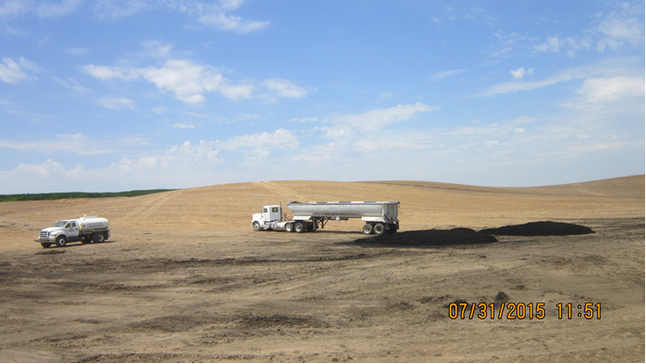

3.3 Hauling Distance

The range of hauling distances for each agency, as well as total ton-miles, are listed in Table 3. The ton-miles provides a metric for the total hauling burden for each agency. In future surveys, hauling distance trends will be tracked to see how they are changing over time.

Table 3. Distance Hauled
 | Minimum distance hauled (miles) | Maximum distance hauled (miles) | Total ton-miles
Central Contra Costa Sanitary District | 0 | 0 | 0
Central Marin Sanitation Agency | 34.6 | 296 | 262,478
City of American Canyon | 64 | 64 | 12,608
City of Benicia Plant | 60 | 60 | 139,800
City of Hayward | 70 | 70 | 167,688
City of Livermore | 14 | 172 | 434,834
City of Millbrae | 131 | 200 | 228,264
City of Palo Alto | 0 | 0 | 0
City of Petaluma | 104 | 104 | 953,576
City of San Jose | 2 | 2 | 106,810
City of San Leandro | 250 | 250 | 1,897,500
City of San Mateo | 140 | 150 | 1,005,820
City of Santa Rosa | 0.5 | 46.75 | 625,844
City of South San Francisco - San Bruno Water Quality Control Plant | 80 | 124 | 1,172,512
City of Sunnyvale | 2 | 250 | 2,303,582
Delta Diablo | 80 | 240 | 1,628,880
Dublin San Ramon Services District | 0 | 0 | 0
East Bay Municipal Utilities District | 90 | 260 | 12,456,330
Fairfield-Suisun Sewer District | 20 | 20 | 224,380
Las Gallinas Valley Sanitary District | 0.15 | 0.15 | 626
Mt. View Sanitary District | 76 | 76 | 57,000
Napa Sanitation District | 0 | 0 | 0
Novato Sanitary District | 0 | 0 | 0
Oro Loma SD | 62 | 62 | 610,142
San Francisco Public Utilities Commission | 69 | 284 | 10,011,832
Sewer Authority Mid Coastside | 5.2 | 5.2 | 7,722
Sewerage Agency of Southern Marin | 43 | 58 | 46,126
Silicon Valley Clean Water | 144 | 250 | 2,594,370
Union Sanitary District | 70 | 252 | 3,101,667
Vallejo Sanitation and Flood Control District | 26 | 26 | 319,592
West County Wastewater District | 57 | 57 | 530,328

3.4 Dewatering Statistics

The on-site methods employed by agencies to dewater biosolids prior to final use included drying beds, centrifuges, presses and dryers. Dewatering equipment employed by each agency, as well as the resulting percentage of solids, is listed in Table 4.

Table 4. Percentage Solids, Dewatering technology type and manufacturer for each agency
Agency | Percent Solids | Dewatering Technology | Equipment Manufacturer
Central Contra Costa Sanitary Agency | 20 to 30% | Centrifuge | Sharples
Central Marin Sanitation Agency | 20 to 30% | Centrifuge | Centrisys CS 18-4
City of American Canyon | 10 to 20% | screw press | OR-TEC Rocker
City of Benicia | 10 to 20% | Belt Filter Press | Ashbrook-Simon-Hartley belt press
City of Hayward | 90 to 99.99% | Drying Bed | drying bed
City of Livermore | 10 to 20% | Belt Filter Press | Ashbrooks
City of Millbrae | 10 to 20% | Belt Filter Press | Andritz (pilgrim) Press. Netzsch cake progressive cavity pump
City of Palo Alto | 20 to 30% | Belt Filter Press | Ashbrook Simon-Hartley, Model WP (i.e., Bellmer Winklepress)
City of Petaluma | 10 to 20% | Screw Press | FKC Co. Ltd
City of San Jose | 90 to 99.99% | Drying Bed | We currently use drying beds
City of San Leandro | 90 to 99.99% | Belt Filter Press, Drying Bed | BDP 2-meter Belt Filter Press
City of San Mateo | 20 to 30% | Centrifuge | Westfalia Bowl&Scroll
City of Santa Rosa* | 10 to 20% | Belt Filter Press | Ashbrook Corp
City of South San Francisco - San Bruno Water Quality Control Plant | 10 to 20% | Belt Filter Press | (2) Komline Sanderson two meter belt filter presses, ten roll
City of Sunnyvale | 20 to 30% | Centrifuge, Belt Filter Press, Drying Bed | Andritz (centrifuge) and FRC (belt press)
Delta Diablo | 20 to 30% | Centrifuge | Flottweg
Dublin San Ramon Services District | 0 to 5% | No dewatering | N/A
East Bay Municipal Utility District | 20 to 30% | Centrifuge | 3 Humbolt; 2 Flottweg
Fairfield-Suisun Sewer District | 20 to 30% | Drying Bed, screw press | FKC Screw Press
Las Gallinas Valley Sanitary District | 5 to 10% | Biosolids are thickened in sludge lagoons | None
Mt. View Sanitary District | 30 to 40% | Centrifuge | Alfa Laval
Napa Sanitation District | 10 to 20% | Belt Filter Press | Ashbrook
Novato Sanitary District | 5 to 10% | sludge lagoons | NA
Oro Loma SD | 40 to 90% | Belt Filter Press | Two - 2.0M BDP Presses
San Francisco Public Utilities Commission | 20 to 30% | Centrifuge and Screw Press | Southeast Plant - Sharples and Gulfcoast Centrifuges; Oceanside Plant - Fukoku Kogyo
Sewer Authority Mid Coastside | 10 to 20% | Belt Filter Press | Ashbrook
Sewerage Agency of Southern Marin | 20 to 30% | Belt Filter Press | BDP Industries 3DP (for the belt press)
Silicon Valley Clean Water | 40 to 90% | Centrifuge | Primary Fournier Filter Press, standby Contec Centrifuge
Union Sanitary District | 20 to 30% | Centrifuge | Andritz
Vallejo Sanitation and Flood Control District | 20 to 30% | Belt Filter Press | Ashbrook
West County Wastewater District | 40 to 90% | Drying bed

Inset 5: City of San Jose, preparation to transfer biosolids to Newby Landfill
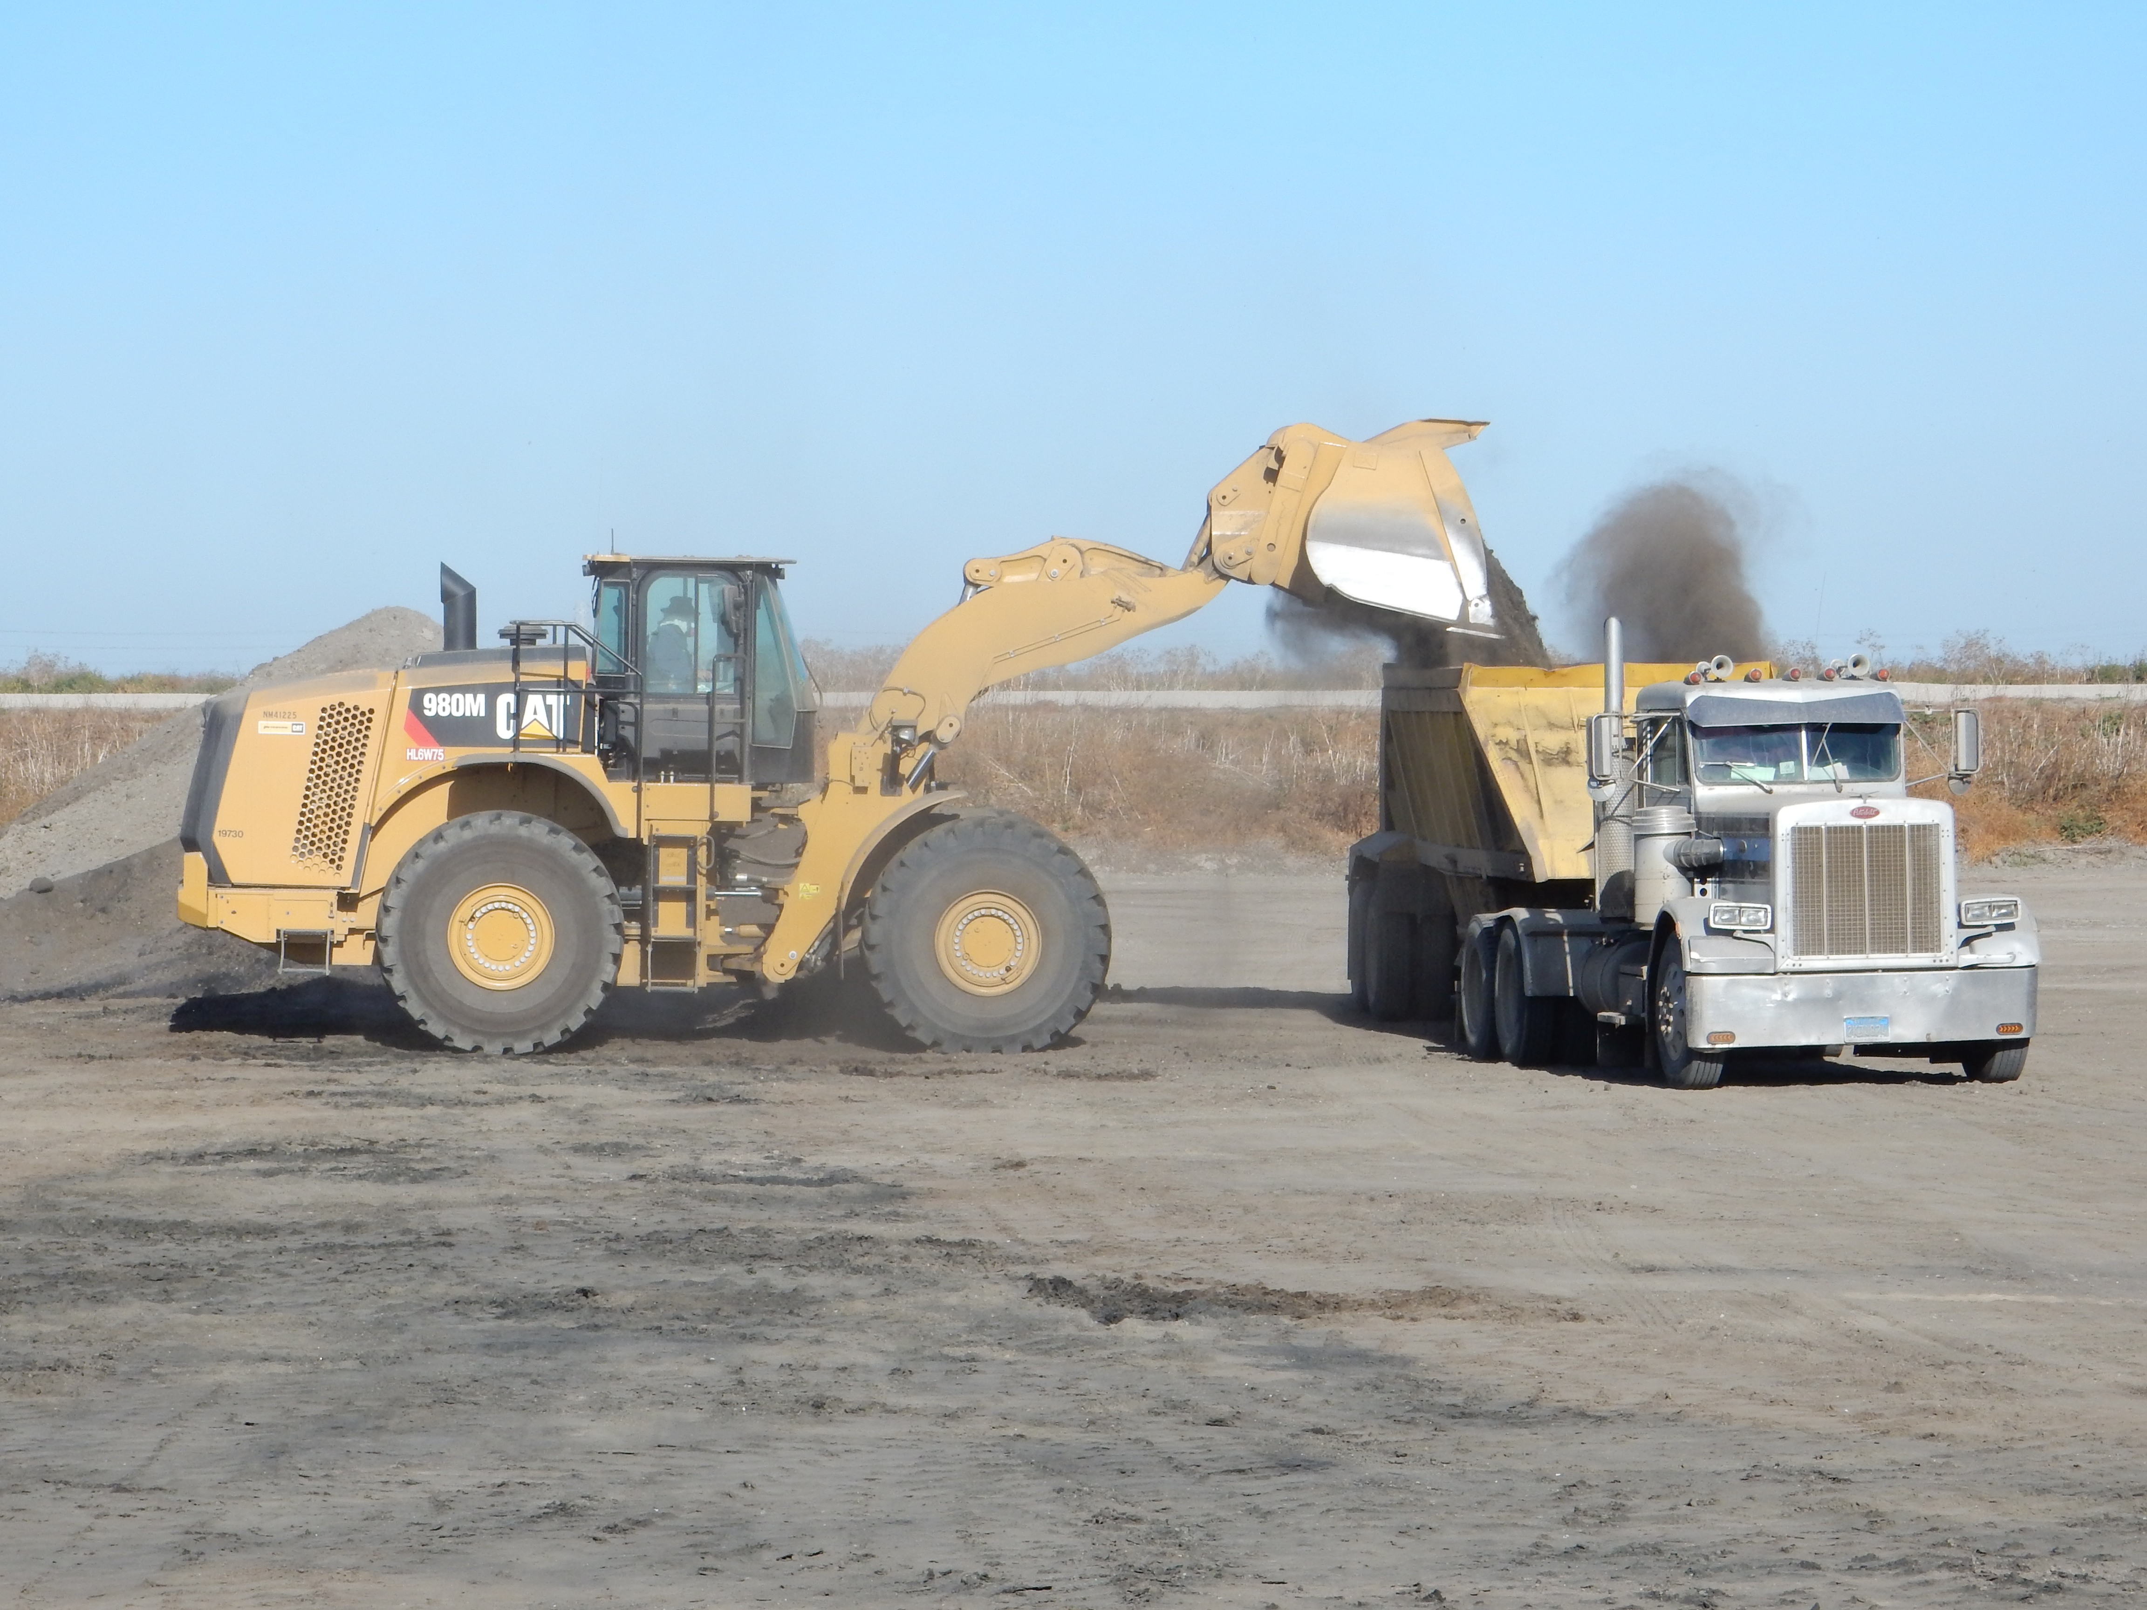

Challenges and Future Planning

4.1 Challenges
Agencies were asked to rank the challenges facing their biosolids program. The following challenges were ranked from the aggregate responses from most to least important.
- Rising costs
- Regulatory restrictions on using biosolids for alternative daily cover
- Securing long term disposal options
- Hauling distance
- Public perception/relations
- Space for drying operations
- Local restrictions on land application
- Wet weather impeding drying operations
- Other
Reasons listed as “other” included lack of space for drying beds, and sea level rise related to height restrictions for levees.

4.2 Future Biosolids Management Plans
The survey asked respondents about their plans for biosolids management in 2016, in five years, and beyond 2025 when ADC may be phased out as a reuse alternative. Only two agencies were planning to make changes in 2016:
- Fairfield-Suisun Sewerage District: “In 2015, the District embarked on a public-private partnership with Lystek to develop a regional Organic Materials Recovery Center (OMRC) at the District WWTP. The OMRC will transform 100% of the District's biosolids into federally-registered liquid fertilizers.” (see inset on pg. 12 on Lystek facility).
- SFPUC: “We plan to: initiate an in-city biosolids gardening demonstration; produce Class A biosolids at our Oceanside Plant via TPAD; develop products for Class A cake; begin construction on our Southeast Plant for Class A conversion; engage in 3 research projects; participate on a hydrolysis pilot project.”

Agencies’ responses on their plans for management in five years and beyond 2025 are listed in Table 5. Of the thirty-one responding agencies, only twelve have concrete plans for beyond 2025.

Table 5. Plans for biosolids in 5 years and beyond 2025
Name of agency | Plans for biosolids in 5 years | Plans for biosolids beyond 2025, if any
Central Contra Costa Sanitary District | Same plan/strategy | Same plan/strategy
Central Marin Sanitation Agency | Participating in various programs to explore biosolids diversification options, such as the Bay Area Biosolids to Energy Coalition. CMSA recently initiated a facilities master plan that include a task to determine future biosolids options.
City of American Canyon | continue ADC and/or land application
City of Benicia - | Same plan/strategy
City of Hayward | unknown
City of Livermore | same plan
City of Millbrae | Currently we are doing a study for class A Biosolids and Pelletizing
City of Palo Alto | Decommission incinerators and switch to dewater and haul facility that would haul unstabilized biosolids for final treatment at another facility | Currently in development
City of Petaluma | Same plan as 2016, while continuing to evaluate future reuse options. | Comply with all biosolids regulations using a diversified biosolids reuse portfolio
City of San Jose | We plan to have a new mechanical dewatering facility and transition out of our drying beds. The City is also looking into diversification options for final use. At this time we are planning to look into diverse contractual options to haul our Class B biosolids for potential further treatment and reuse. | We plan to have a diversified portfolio that includes multiple contracts for reuse. We are also transition our current mesophilic digestion process to a Temperature Phased Anaerobic Digestion (TPAD) process to provide flexibility to add batch tanks in the future if there is the need to provide Class A biosolids.
City of San Leandro | Evaluating technologies to increase gas production and reduce biosolids production
City of San Mateo | Similar treatment | Likely shifting to thermophilic AD/ increase digester # for Class A product.
City of Santa Rosa | Same strategy at this point | Same strategy at this point
City of South San Francisco - San Bruno Water Quality Control Plant | Landfill
City of Sunnyvale | Same plan as 2016.
Delta Diablo | Investigating biosolids to energy options and interested in reducing the volume of biosolids produced
Dublin San Ramon Services District | We may dewater a small portion of the biosolids in 5 years | We are exploring a number of options, we are currently working on an updated treatment plant and biosolids master plan
East Bay Municipal Utility District | unknown, likely not landfill ADC
Fairfield-Suisun Sewer District | The District intends to send 100% of its biosolids to the Lystek OMRC | The District intends to send 100% of its biosolids to the Lystek OMRC
Las Gallinas Valley Sanitary District | Most likely same as current
Mt. View Sanitary District | We are looking at other possibilities: Lystek, Bioforce | We are working on it
Napa Sanitation District | Continue existing plan/strategy | Continue existing plan/strategy
Novato Sanitary District | Continue to use the DLD | Continue to use the DLD
Oro Loma Sanitary District | We negotiated a fixed price (with CPI escalator) until 2027. | We negotiated a fixed price (with CPI escalator) until 2027.
San Francisco Public Utilities Commission | In five years, we plan to be actively engaged in soil blending projects, and we expect the conversion of our Southeast plant to Class A to be near completion. | We plan: a complete phase-out from landfill; to develop multiple outlets including soil blending and land application; to mature the local biosolids to soil demonstrations; to actively collaborate with academia on monitoring trace organic compounds; to strengthen soil blending operations using San Francisco's Class A biosolids as feedstock; to strengthen regional partnerships promoting biosolids safety and benefits.
Sewer Authority Mid Coastside | No change
Sewerage Agency of Southern Marin | Same as above | The Waste Management site is planning to incorporate composting Class A onsite before 2025 once funding is secured.
Silicon Valley Clean Water | Not defined
Union Sanitary District | Possibly increase percentage sent to composting facility and possibly pilot small amount of solids ohter option like Lystek.
Vallejo Sanitation and Flood Control District | Continue to land apply at Tubbs | Land apply at Tubbs as long as possible
West County Wastewater District | Same plan/strategy as 2016.

Public Outreach

5.1 Marketing
The survey asked whether agencies directly market their biosolids products. Only Santa Rosa replied in the affirmative, that they market their compost. In Southern California, seven of 33 agencies surveyed report that they directly market their biosolids products.

5.2 Outreach and Education
Agencies were asked whether they do any outreach or education pertaining to their biosolids programs, and via what venue. Only six agencies replied that they do outreach pertaining to biosolids, and they use a combination of YouTube videos, their website and print media. In Southern California, sixteen of the 33 respondents reported they use social media to promote their biosolids program, as illustrated in Figure 5.

Seventeen agencies in this survey replied that they do not do outreach pertaining to biosolids in particular, but do with respect to their other programs. Seven agencies replied that they do no outreach at all.

Biosolids Staff

The final survey question asked respondents whether their agencies have dedicated biosolids staff, and if so, how many full time equivalent positions (FTUs). Twenty-nine agencies responded that they do not have dedicated staff, with the following exceptions:

- City of Santa Rosa – 9 FTUs
- City of Sunnyvale – 2 contractors

Figure 5. Number of agencies doing biosolids marketing and publicity via traditional and social media.

Inset 6. City of San Jose dredges sludge from lagoons.
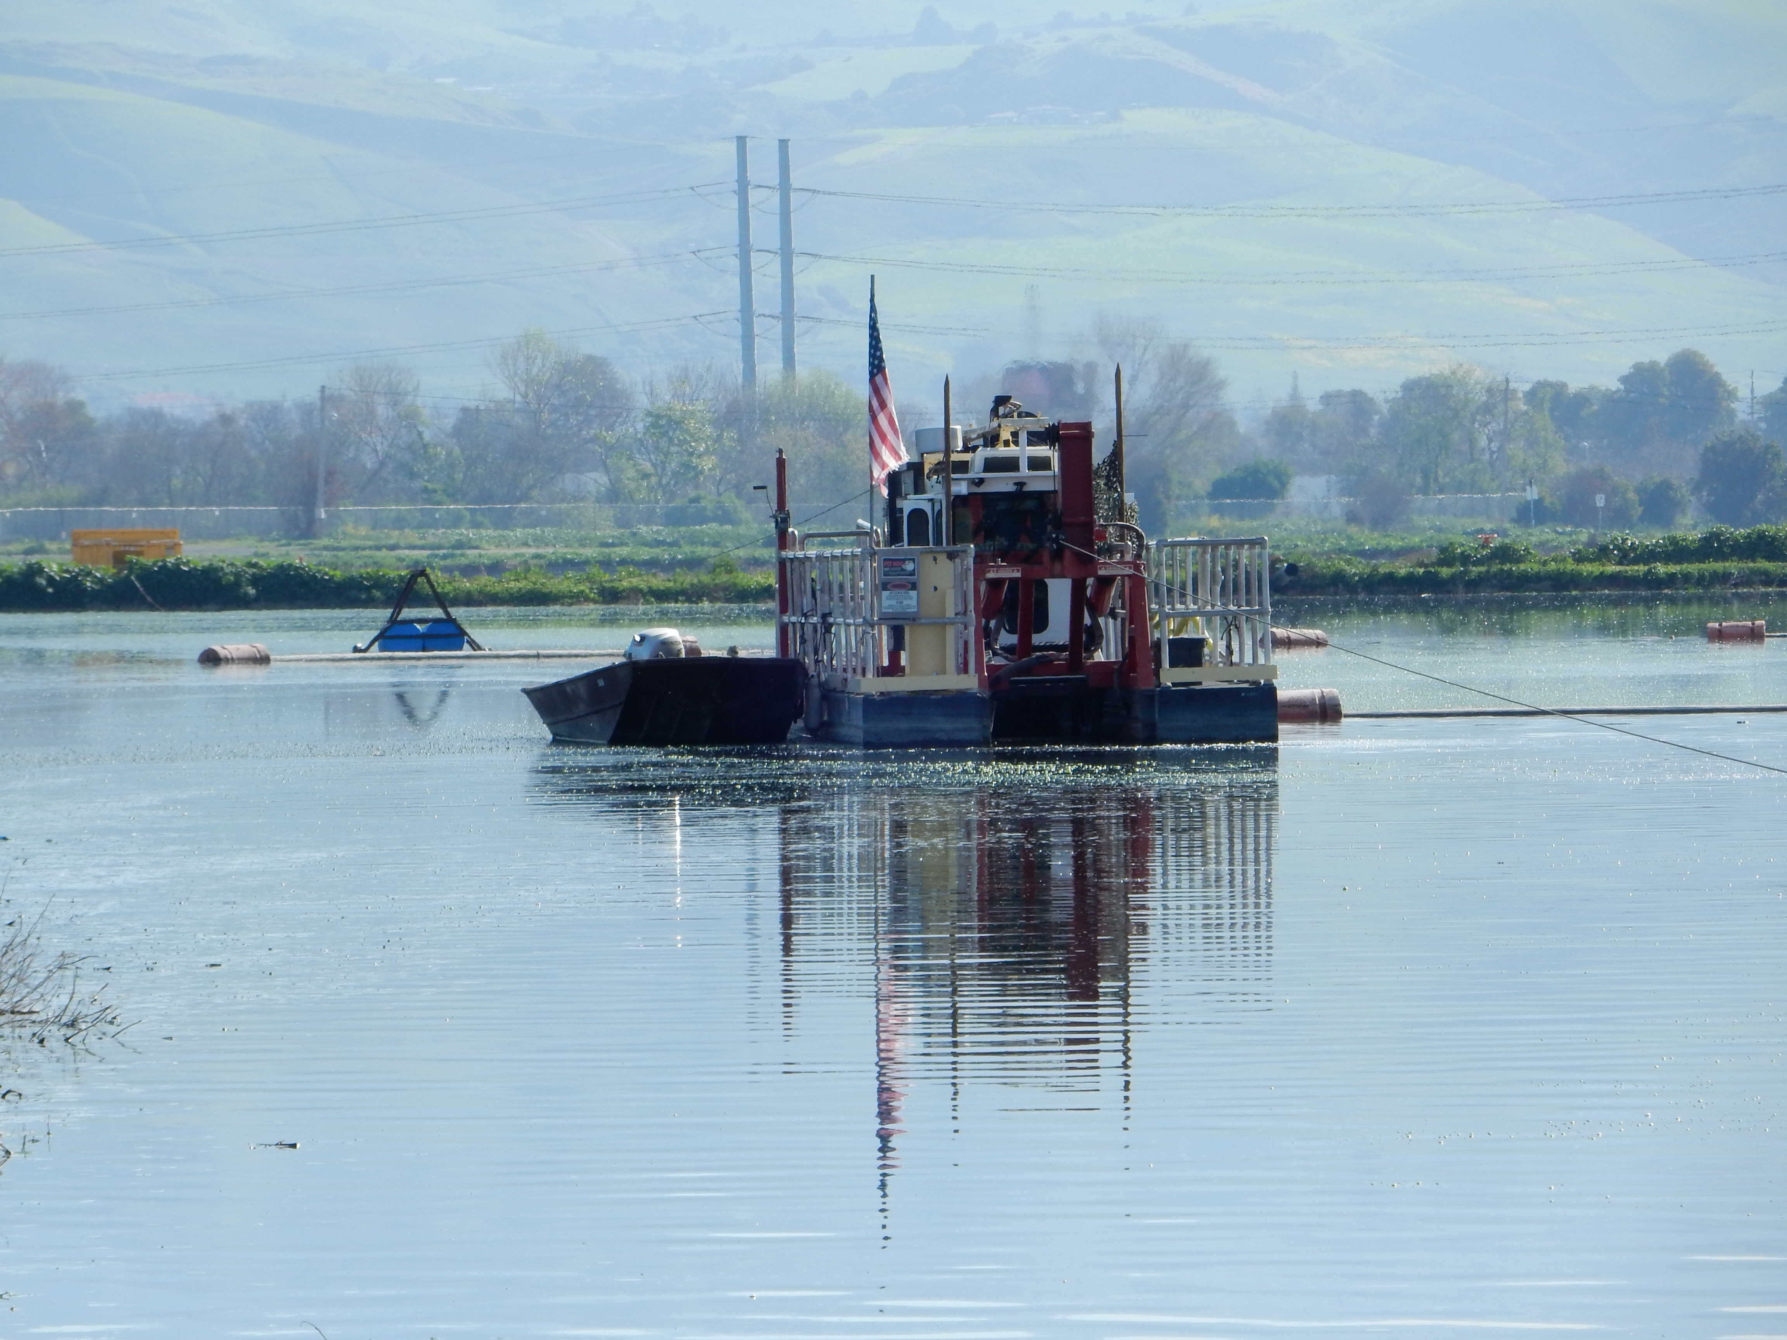

Future surveys

BACWA intends to repeat this survey in 2018, and every two years thereafter. This will give the Region the ability to track changes in biosolids trends over time. Additionally, the Biosolids Committee may choose to expand the scope of this survey to a greater geographical area. BACWA member agencies are all permitted by the San Francisco Regional Water Quality Control Board, but the Regional Water Board’s jurisdiction does not have a bearing on biosolids regulation or management.

If the next two years brings clarity on the future regulatory scenarios for biosolids reuse and disposal in California, future survey questions may be refined to better understand how agencies are responding to this shifting landscape.

APPENDIX A – AGENCY DATA: 2015 Reuse and Disposal Alternatives

Central Contra Costa Sanitary District
 | Destination 1
type | incineration
location | onsite
wet tons | 72,297
cost ($/ton) | $0
distance (miles) | 0

Central Marin Sanitation Agency
 | Destination 1 | Destination 2 | Destination 3 | Destination 4 | Destination 5
type | ADC | Land Application | Land Application | Land Application | Other Products
location | Redwood Landfill, Novato | Synagro's Sonoma County land application site | Synagro's Solano County land application site | Synagro's Merced County land application site | Lystek Organic Material Recovery Center @ FSSD
wet tons | 2,876 | 0 | 1,567 | 0 | 0
cost ($/ton) | $45.50 | $38.33 | $40.08 | $23.58 | $89.50
distance (miles) | 34.6 | 36.4 | 104 | 296 | 86.4

City of American Canyon
 | Destination 1
type | ADC
location | Hay Road Landfill, Solano County
wet tons | 197
cost ($/ton) | $0.00
distance (miles) | 64

City of Benicia
 | Destination 1
type | ADC
location | Hay Road Landfill, Vacaville, California
wet tons | 2,330
cost ($/ton) | $79.28
distance (miles) | 60

City of Hayward
 | Destination 1
type | Landfill
location | Altamont Landfill & Resource Recovery Facility
wet tons | 2395.54
cost ($/ton) | not reported
distance (miles) | 70

City of Livermore
 | Destination 1 | Destination 2
type | ADC | Land App
location | Vasco Rd Landfill | Robinson Ranch,Winton,CA
wet tons | 5,751 | 2,060
cost ($/ton) | $40.00 | $40.00
distance (miles) | 14 | 172

City of Millbrae
 | Destination 1 | Destination 2 | Destination 3
type | Land App | Land App | Compost
location | Merced County | Sacramento County | Merced County
wet tons | 223 | 916 | 121
cost ($/ton) | $54.95 | $54.95 | $54.95
distance (miles) | 131 | 100 | 131

City of Palo Alto
 | Destination 1
type | incineration
location | onsite
wet tons | 6,936
cost ($/ton) | $0
distance (miles) | 0

City of Petaluma
 | Destination 1
type | ADC
location | Hay Road Landfill
wet tons | 9,294
cost ($/ton) | $43.35
distance (miles) | 104

City of San Jose
 | Destination 1
type | ADC
location | Newby Island Landfill
wet tons | 53,405
cost ($/ton) | $30.00
distance (miles) | 2

City of San Leandro
 | Destination 1
type | Land App
location | Robinson Ranch, Merced
wet tons | 7,590
cost ($/ton) | $36.95
distance (miles) | 250

City of San Mateo
 | Destination 1 | Destination 2
type | Land App | ADC
location | Solano Co, | Potrero Hills Landfill-Contra Costa
wet tons | 3,828 | 3,083
cost ($/ton) | $34.75 | $34.75
distance (miles) | 150 | 140

City of Santa Rosa
 | Dest. 1 | Dest. 2 | Dest. 3 | Dest. 4 | Dest. 5 | Dest. 6 | Dest. 7 | Dest. 8 | Dest. 9
type | landfill | Land app | Land App | Land App | Land App | Land App | Land App | Compost | Storage
location | landfill | South County land app | South County land app via storage | stone farm | stone farm via storage | brown farm | brown farm via storage | City of Santa Rosa Compost Facility | Alpha Storage for use in 2016
wet tons | 2349 | 9382 | 2591 | 22 | 399 | 180 | 568 | 8514 | 3971
cost ($/ton) | $5.33 | $5.33 -$7.96 | $6.21 - $8.83 | $4.30 | $3.24 | $3.24 | $3.24 | $1.84 | $3.24
distance (miles) | 24 | 36.5 - 57 | 36.5 - 57 | 6.9 | 4.9 | 4.5 | 4.5 | 0.5 | 6

City of South San Francisco - San Bruno Water Quality Control Plant
 | Destination 1 | Destination 2
type | Landfill | ADC
location | Newby Island Landfill | Potrero Hills Landfill, Suisun City
wet tons | 12,753 | 1,228
cost ($/ton) | $55.00 | $55.00
distance (miles) | 80 | 124

City of Sunnyvale
 | Destination 1 | Destination 2 | Destination 3 | Destination 4 | Destination 5 | Destination 6
type | Land App | Land App | ADC | ADC | Compost | Onsite Disposal
location | Sacramento County | Merced County | Vasco Road Landfill | Potrero Hills Landfill | Central Valley Composting Facility | Sunnyvale Biosolids Monofill
wet tons | 6,685 | 5,015 | 93 | 609 | 321 | 2,641
cost ($/ton) | $135.00 | $135.00 | $135.00 | $135.00 | $135.00 | $14.63
distance (miles) | 130 | 250 | 80 | 160 | 220 | 2

Delta Diablo
 | Destination 1 | Destination 2 | Destination 3
type | Land App | ADC | Compost
location | Various Sacramento and Solano County sites | Potrero Hills Landfill | Synagro's El Nido Compost Facility
wet tons | 10,800 | 1,119 | 114
cost ($/ton) | $32.18 | $32.18 | $50.42
distance (miles) | 140 | 80 | 240

Dublin San Ramon Sanitary District
 | Destination 1
type | Onsite Disposal
location | DSRSD
wet tons | 37,500
cost ($/ton) | $3.50
distance (miles) | 0

East Bay Municipal Utilities District
 | Destination 1 | Destination 2
type | ADC | Land App
location | landfill ADC | land application
wet tons | 43,001 | 33,024
cost ($/ton) | $30.40 | $36.22
distance (miles) | 90 | 260

Fairfield-Suisun Sewer District
 | Destination 1
type | ADC
location | Potrero Hills Landfill
wet tons | 11,219
cost ($/ton) | $22.00
distance (miles) | 20

Las Gallinas Valley Sanitary District
 | Destination 1
type | Onsite Disposal
location | LGVSD
wet tons | 4,170
cost ($/ton) | $11.00
distance (miles) | 0.15

Mt. View Sanitary District
 | Destination 1
type | ADC
location | B&J Hay Road Landfill
wet tons | 750
cost ($/ton) | $15.00
distance (miles) | 76

Napa Sanitation District
 | Destination 1
type | Onsite Disposal
location | NSD
wet tons | 66,362
cost ($/ton) | $0.00
distance (miles) | 0

Novato Sanitary District
 | Destination 1
type | Onsite Disposal
location | Novato Designated Land Disposal
wet tons | 18,000
cost ($/ton) | $7.72
distance (miles) | 0

Oro Loma SD
 | Destination 1
type | ADC
location | Altamont Landfill
wet tons | 9,841
cost ($/ton) | $33.50
distance (miles) | 62

San Francisco Public Utilities Commission
 | Destination 1 | Destination 2 | Destination 3 | Destination 4 | Destination 5 | Destination 6 | Destination 7
type | Land App | Land App | Land App | Compost | ADC | ADC | ADC
location | Sonoma County | Solano County | Sacramento County | Merced | Hay Road Landfill | Potrero Hills Landfill | Altamont Landfill
wet tons | 2,349 | 21,549 | 4,324 | 3,371 | 20,376 | 14,512 | 2,125
cost ($/ton) | $42.32 | $49.81 | $82.64 | $94.42 | $65.12 | $64.43 | $66.06
distance (miles) | 69 | 126 | 246 | 284 | 124 | 136 | 136

Sewer Authority Mid Coastside
 | Destination 1
type | Landfill
location | Ox Mountain Landfill
wet tons | 1,485
cost ($/ton) | $42.08
distance (miles) | 5.2

Sewerage Agency of Southern Marin
 | Destination 1 | Destination 2
type | ADC | Land App
location | Waste Management Inc. (Redwood Landfill), | Synagro, Land Application
wet tons | 722 | 260
cost ($/ton) | $40.31 | $22.46
distance (miles) | 43 | 58

Silicon Valley Clean Water
 | Destination 1 | Destination 2 | Destination 3 | Destination 4 | Destination 5
type | Compost | Land App | Land App | Land App | ADC
location | Central Valley Compost | Solano County | Merced County | Silva Ranch Sacramento County | Potrero Hills Landfill
wet tons | 2,981 | 67 | 120 | 4,330 | 5,044
cost ($/ton) | $150.00 | $36.98 | $36.98 | $41.98 | $45.01
distance (miles) | 250 | 150 | 250 | 250 | 144

Union Sanitary District
 | Destination 1 | Destination 2 | Destination3 | Destination 4 | Destination 5
type | Compost | Land App | Land App | Land App | ADC
location | Central Valley Composting Facility | Merced County | 9896 WT | Solano County | Vasco Road Landfill
wet tons | 3,470 | 3,319 | 9,896 | 98 | 2,450
cost ($/ton) | $49.27 | $30.41 | $30.41 | $30.41 | $30.41
distance (miles) | 252 | 220 | 161 | 147 | 70

Vallejo Sanitation and Flood Control District
 | Destination 1
type | Land App
location | Tubbs Island, Sonoma County
wet tons | 12,292
cost ($/ton) | $12.00
distance (miles) | 26

West County Wastewater District
 | Destination 1
type | ADC
location | Keller Canyon, Pittsburg
wet tons | 9,304
cost ($/ton) | $0.00
distance (miles) | 57

See SCAP Biosolids Trends Survey https://bacwa.org/wp-content/uploads/2017/06/2016-SCAP-Biosolids-Trends-Update-3.pdf
https://bacwa.org/wp-content/uploads/2017/01/1-11-17-Sustainability-for-biosolids-use-at-landfills.pdf
Survey questions may be viewed by following this link: https://www.surveymonkey.com/r/LXKF3RL
SCAP Biosolids Trends Survey https://bacwa.org/wp-content/uploads/2017/06/2016-SCAP-Biosolids-Trends-Update-3.pdf

