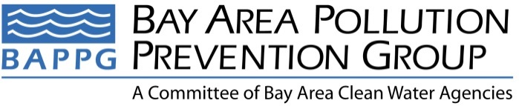

2015 Annual Report
Covering reporting period of 1/1/15 – 12/31/15
2015-2016 Fiscal Year Report
Covering reporting period of 7/1/15 – 6/30/16

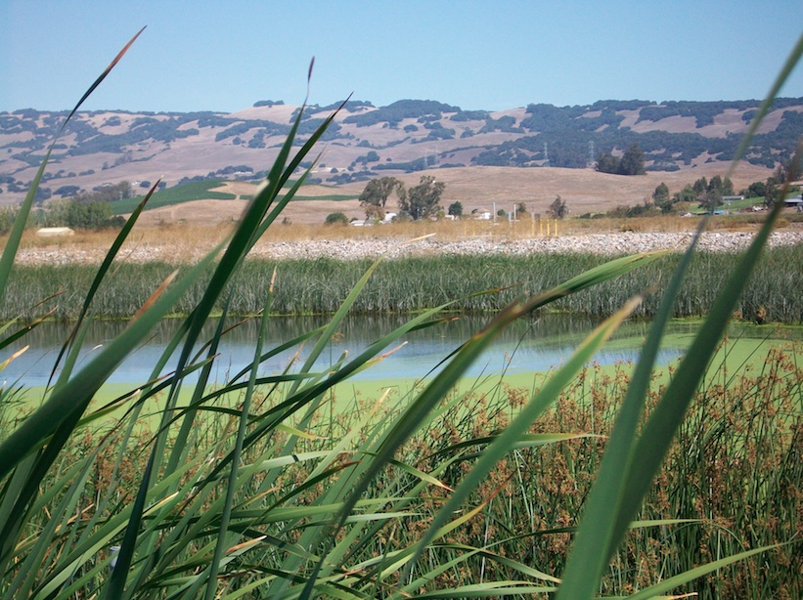
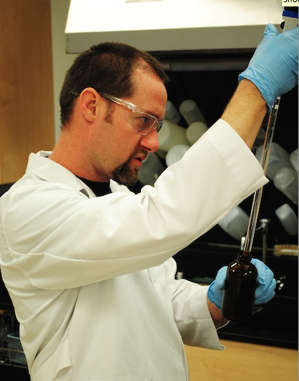


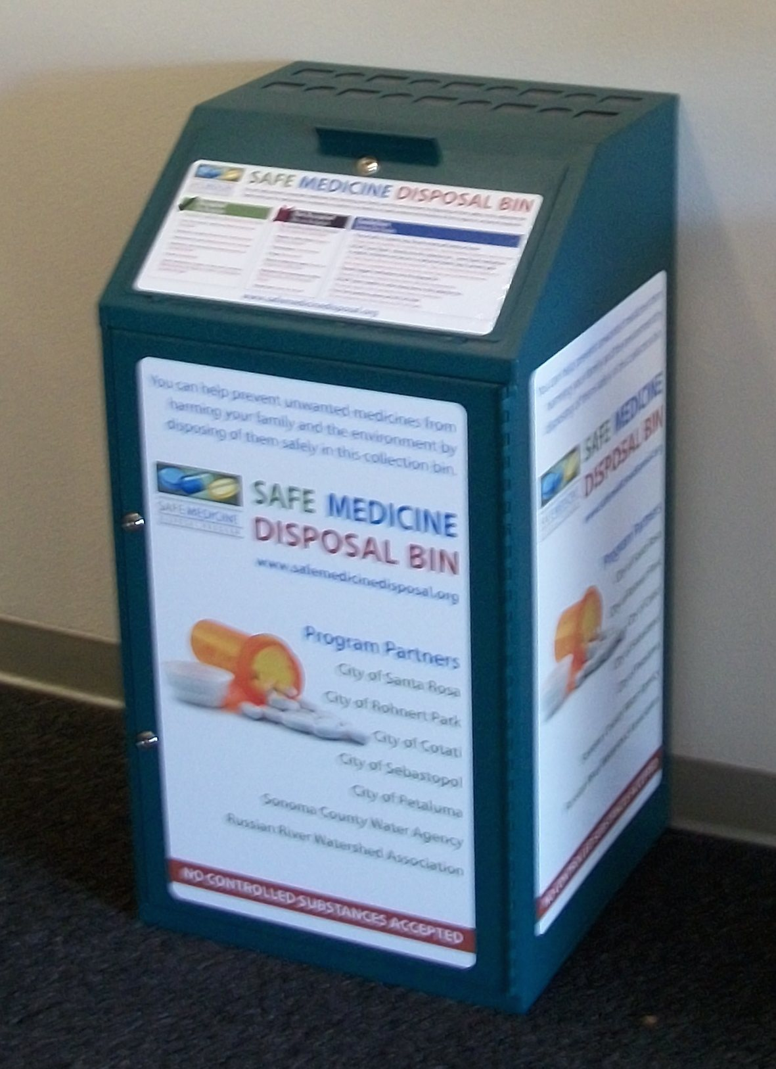

BAPPG Chair: Robert Wilson  BAPPG Co-Chair: James Parrish  BAPPG Vice Chairs: Doug Dattawalker and Joe Neugebauer | Prepared by: Joe Neugebauer  Submitted to: Bay Area Clean Water Agencies  Date: 8/17/16

2015-16 Fiscal Year Report
July1, 2015 – June 30, 2016

Executive summary

The Bay Area Pollution Prevention Group (BAPPG), a subcommittee of Bay Area Clean Water Agencies (BACWA), is comprised of 43 Bay Area wastewater agencies that work together to coordinate pollution prevention activities and leverage resources for smaller agencies to reduce the amount of toxic pollutants discharged into the San Francisco bay and local waterways. Wastewater agency representatives meet monthly to share information, leverage resources and develop regional activities that help member agencies meet regulatory outreach requirements and BAPPG goals.

2015-16 Committee Updates

All files pertaining to BAPPG are now being added to the BACWA BAPPG webpage. This includes meeting agendas, meeting minutes, reports, presentations, and information on pollutants of concern.

2016-2017 BAPPG officers were selected:
- Chair – Robert Wilson, City of Petaluma
- Co-Chair – James Parrish, Regional Water Quality Control Board
- Co-Vice Chair – Doug Dattawalker, Union Sanitary District
- Co-Vice Chair – Joe Neugebauer, West County Wastewater District

CURRENT PROJECT UPDATES

This report serves as an update to BACWA and member agencies for all BAPPG projects, by pollutant, which took place from July 1, 2015 through June 30, 2016.
- Copper
- Dioxin
- Fats Oils and grease (FOG)
- Mercury and Silver
- PCBs and Hazardous Demolition Waste
- Pesticides
- Pharmaceuticals
- Triclosan
- Trash and Wipes

1. Pollutant: Copper

Pollutant Description
Copper pipe corrosion has been a major concern to the wastewater community for more than a decade. For many years, the messages have focused on proper installation, including the use of a water-based flushable flux. In California, there are also alternatives to copper pipe for potable and non-potable installations, such as PEX.

Key Messages
- Select only ASTM B813 water-flushable flux rather than petrolatum-based flux (which is not flushable and increases pipe corrosion rates)
- Incorporate additional BMPs during design, reaming, cleaning, and building commissioning that will reduce pipe corrosion rate

Project | Description | Timeline | Budget
Outreach to Plumbers and Building Inspectors | Offered to provide presentations to plumbing unions and building inspector associations about plumbing installation BMPs. Offered to provide building inspector association with the preliminary results of the 2014 BAPPG study regarding life cycle and worker safety of copper versus PEX plumbing. | July 2015-June 2016 | $500

Results
In August 2015, BAPPG conducted a presentation and discussion with the International Association of Plumbing and Mechanical Officials (IAPMO), a professional society for building inspectors, to discuss copper versus PEX life cycle analyses and flux issues. This was the first time BAPPG presented findings regarding life cycle and worker safety issues of the two plumbing materials. The audience included building inspectors, contractors, and PVC (not PEX) distributors. There was significant push-back from audience members who clearly prefer copper as a plumbing material.

Next Steps
BAPPG has been delivering the copper plumbing BMP messages for more than a decade, yet BAPPG learned in 2013 that the “best practice” of selecting water-flushable flux (“Key Message #1, and consistent with the Universal Plumbing Code standard) is being virtually ignored throughout the plumbing sector. In addition, in 2014, Stephanie Hughes completed an analysis of copper versus PEX from life cycle and worker safety perspectives that included information to support the use of PEX installations. These findings initiated discussions within BAPPG regarding whether to update plumbing messages.

The August 2015 presentation was the first time BAPPG reached out to the building inspector and contractor community regarding the lifecycle and worker safety findings. The resulting discussion made it evident that building contractors and inspectors will continue to use and approve of plumbing materials that they believe to be the most reliable irrespective of lifecycle or wastewater impacts.

Prior to continuing or developing outreach actions, it may be appropriate to update the copper source analysis for wastewater. The copper source analysis often cited within BAPPG is a 1996 document incorporating an assumption from a 1994 document. At the August 2015 IAPMO meeting, participants questioned the date of the analysis and suggested that there may be new or different sources at this time.

2. Pollutant: Dioxin

Pollutant Description
When combustibles are burned, many pollutants, including dioxins, are emitted into the air, dispersed over the land and are ultimately transported in runoff when it rains. These pollutants can then get into the wastewater stream via inflow and infiltration, so controlling burning ultimately helps reduce these pollutants in stormwater and wastewater. Since a previous BACWA study found that dioxins are uncontrollable in wastewater, BAPPG’s approach to reducing this pollutant at its source is to discourage the burning of wood and holiday wrapping paper, and to partner with the Bay Area Air Quality Management District (BAAQMD) to support their “Winter Spare the Air” campaign.

Key Messages
- Don’t burn holiday wrapping paper or wood, especially during “Winter Spare the Air” days.

Project | Description | Timeline | Budget
Wrapping paper press release | Worked with O’Rorke, Inc. to develop a press release discouraging the burning of wrapping paper and wood. The release was distributed during an alternative wrapping paper press event, held at Westfield Mall in San Francisco on December 10, 2015. The event and press release were covered by the local media as well as online news sources. | December 10, 2015-January 1, 2016 | $2,000

Results
- 12 total stories
- Nine radio stories, all on KCBS
- Two TV stories, one on KTSF and one on KGO
- One online story with World Journal
- The total publicity value for this coverage is $12,242. Radio publicity values are based on Arbitron P12 + Cume Estimate
Next Steps
Dioxin is not a pollution prevention issue that significantly affects wastewater treatment. To allocate BAPPG’s budget on higher-priority pollution prevention issues, BAPPG will not be funding a dioxin program during fiscal year 2016/2017. Monitoring at individual treatment plants will continue and funding a dioxin campaign will be reassessed if results indicate additional sources of the pollutant.

Materials
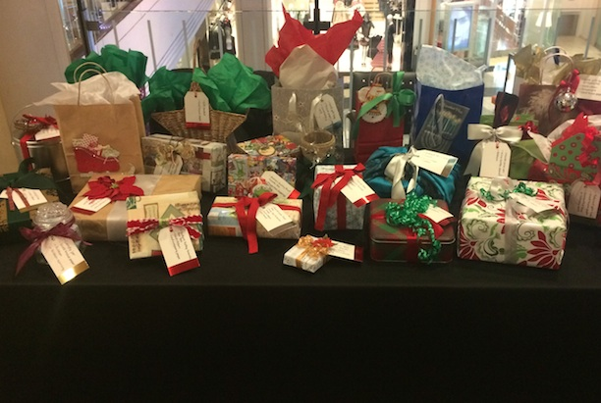
Poster from event at Westfield Alternative Gift Wrap station

3. Pollutant: Fats, Oils and Grease (FOG)

Pollutant Description
FOG is a top priority due to the associated regulatory and financial impacts to member agencies. FOG is a major problem for sewer systems, causing sewer back-ups, sewer overflows onto streets, and foul sewer odors. In addition, cities can spend millions of dollars a year in infrastructure improvements and responding to grease-related sewer blockages.

Key Messages
- Don’t pour grease down the drain – collect and recycle used cooking oil.

Project | Description | Timeline | Budget
Spanish Holiday Outreach | Through Univision Hispanic Radio (KSOL 98.9 FM, KSQL 99.1 FM and KBRG 100.3 FM), BAPPG promoted messages of proper grease disposal to the South Bay, East Bay and North Bay. Outreach included:  - PSA and collateral distribution at events  - Educational flyers  - Online digital banner for audio streaming spots  - Baywise.org promotion | November – December 2015 | $8,000

Results
- 60 weekly spots
- 180 total campaign spots
- 580,766 weekly gross impressions
- 1,742,300 total campaign gross impressions
- $0.0042 cost per impression

Project | Description |  | Timeline |  | Budget
Food Truck Regional Outreach |  | O’Rorke is developing a flyer designed to educate food truck owners and operators about proper Fats, Oils and Grease disposal and storage practices. |  | November 2015 – Present |  | $3,500

Results
This is an ongoing project. O’Rorke is currently updating the flyer to include FOG drop-off locations throughout the Bay Area.

Next Steps
In addition to continuing BAPPG’s FOG campaign with Univision, BAPPG plans to host a joint BAPPG / BACWA Pretreatment Committee meeting to present on mobile food trucks and discuss opportunities surrounding regional best management practice (BMP) and collateral development.

Materials

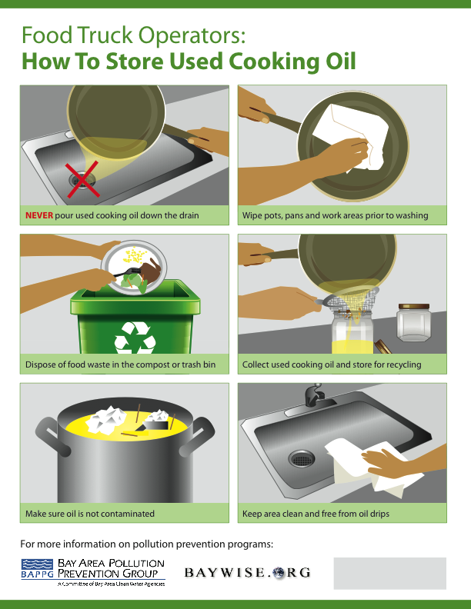

Food Truck FOG outreach flyer

4. Pollutant: Mercury and Silver

Pollutant Description
Outreach regarding best management practices for dental amalgam and silver fixer waste is essential to ensure member agencies continue to meet regulatory standards and prevent pollution of receiving waters.

Key Messages
- Dental amalgam and silver fixer wastes are hazardous and shall not be disposed in dental office sinks.
- Incorporate BMPs for dental amalgam, silver fixer, and other hazardous wastes within a dental office.
- The mandated use of BMPs and amalgam separators has significantly decreased the mercury loads into the sewer.

Project | Description | Timeline | Budget
Dental Assistant/ Hygienist Outreach | Stephanie Hughes served as a guest speaker in dental assistant / hygienist classes in local colleges throughout the Bay Area. | July 2015-June 2016 | $5,000

Results
Reached a total of 237 students and instructors from July 1, 2015 – June 30, 2016 at the following site visits:
- San Jose City College (one class)
- Santa Rosa Jr. College (one class)
- Carrington College, Pleasanton (two classes)
- San Francisco City College (one class)
- College of Marin, Novato (one class)
- Foothill College, Los Altos (two classes)
- Mt Diablo Adult Ed, Concord (three classes)

Next Steps
Continue to provide the guest speaker to local colleges. The instructors have come to rely on these annual visits and have incorporated BAPPG’s program into their instructional calendar. Further, this is a very relevant audience for other messages, such as wipes, microbeads, and triclosan.

5. Pollutant: PCBs and other Hazardous Demolition Waste

Pollutant Description
PCBs were components of external caulk and sealants prior to 1980. The EPA has developed messages about proper identification and management during building demolition and remodeling. BAPPG also identified a need to assemble information about hazardous material identification and management prior to building demolition, because the materials and regulations are numerous. Recent outreach efforts build on a brochure and website created by BAPPG in 2012-2013.

Key Messages
- Identify PCB and other hazardous materials prior to demolition.
- Inspect buildings remodeled prior to 1980 for PCB-containing exterior caulk and sealants.
- During removal of PCBs and other hazardous materials, protecting building residents and demolition staff and disposing of wastes according to state and federal disposal laws.
- Utilize the BAPPG brochure and companion web site for more information: www.baywise.org/demolition.

Project | Description | Timeline | Budget
PCB and Demolition Outreach | Stephanie Hughes on-call to provide support of the web site and outreach opportunities. | Calendar Year 2015 | $500

Results
Stephanie Hughes reviewed the website and updated links in the fall of 2015. Stephanie also attended a regional PCB TMDL / demolition stakeholder meeting in Oakland and gave a brief presentation to ensure awareness of this online resource.

Next Steps
Continue to educate building inspectors and contractors about identifying and disposing PCB-containing products. Develop outreach messages targeting residents and homeowners. Reach out to the California State Licensing Board to request that they link their website to the BAPPG website. Continue to request that BAPPG members and local jurisdictions link their inspection websites to the BAPPG website.

6. Pollutant: Pesticides

Pollutant Description
Improper indoor and outdoor application of pesticides can result in chemical runoff into the sewer systems and receiving waters, leading to lower pollutant removal efficiencies at treatment plants as well as aquatic ecosystem degradation.

Key Messages
- Promote integrated pest management and less-toxic products as alternatives to pesticides.
- Fipronil (awaiting better alternatives prior to developing messaging).

Project | Description | Timeline | Budget
OWOW | OWOW is a Bay Area-wide outreach program that promotes the use of less-toxic pest control methods and products in the home and garden through local retailers. | Calendar Year 2015 | $10,000

Results
- Coordinated program implementation with major chains Home Depot, Orchard Supply Hardware (OSH), and Ace Hardware National.
- Printed an inventory of the following: fact sheets, shelf tags, and Home Depot-specific pocket guide, from which participating agencies could purchase materials.
- Updated less-toxic Product Lists: general plus OSH and Home Depot-specific lists/labels.
- Maintained Our Water, Our World website.
- Provided Ask-the-Expert service with 24-hour turnaround on answers to pest management questions.
- Provided on-call assistance (e.g., display set-up, training, IPM materials review) to specific stores (e.g., OSH, Home Depots).
- Provided print and web advertising – Chinook Coupon Book.
- Worked with Chinook Book to make changes to the mobile application (app) – OWOW mobile app.
- Continued to work with select local agencies and with Home Depot to implement, a pilot enhanced program in 10 Home Depots in the greater Bay Area and Sacramento. The enhanced program was implemented primarily by the IPM Advocates.
- Developed and conducted advanced regional trainings for Home Depot.
- Advocates trained 1,000 store employees and reached 4,300 customers at Our Water, Our World store events in 2015.

Materials
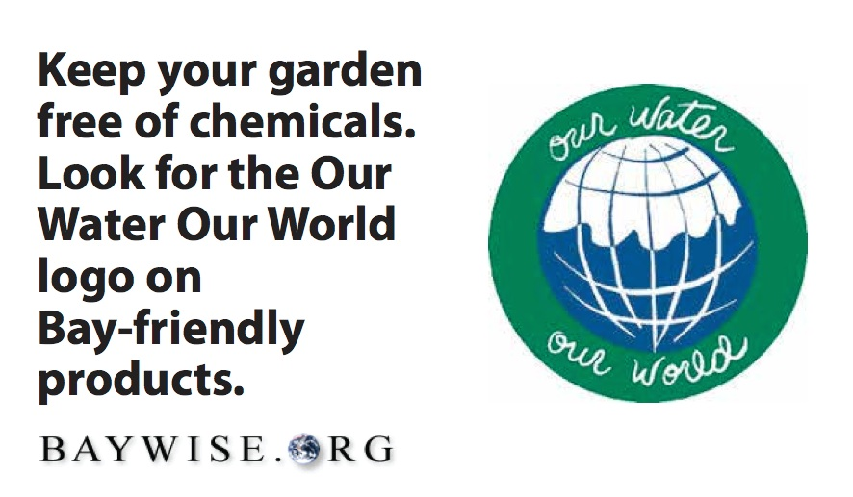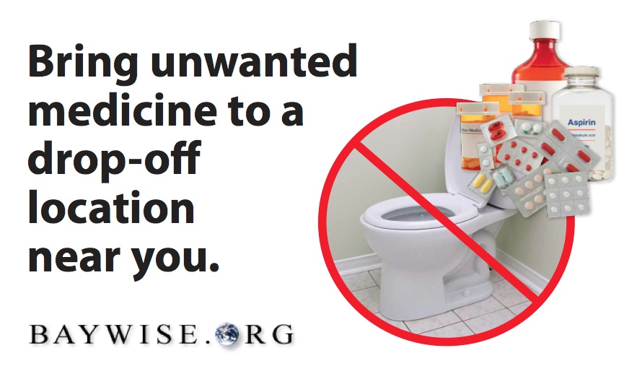
Chinook Book mobile ads

Project | Description | Timeline | Budget
Regulatory Tracking and Communications | Identify pesticide regulatory actions at federal and state level. Communicate with regulatory to ensure that wastewater issues are included in the analyses. Evaluate flea products, comparing pathways to sewers and develop updated recommendations to reduce impact to sewers. | July 2015-June 2016 | $32,495

Results
- Coordinated with BAPPG to update the list of highest priorities pesticides for BACWA’s attention. Created an updated pesticides watch list for tracking purposes.
- Provided a “crystal ball” schedule of anticipated pesticide regulatory activities on these pesticides. Prepared a detailed tracking spreadsheet for EPA activities, with docket numbers and EPA contact emails, and a near-term priorities tracking summary, updated monthly or bimonthly.
- Tracked pesticide-related regulatory activities by EPA and DPR and new scientific information that have significant potential to affect BACWA member agencies. Notified BAPPG of such items as they arose. On the basis of regulatory documents, relevant scientific information, and the regulatory context, made recommendations regarding regulatory participation or other follow-up steps on multiple EPA and DPR actions relating to pesticides including copper, pyrethroids, imidacloprid, and fipronil. When so directed, provided key points for comments and reviewed draft comment letters by BACWA and its allies.
- Based on existing open lines of communication with pesticide regulators, pesticide manufacturers, and scientists researching pesticides in wastewater, notified BAPPG of important information obtained through these contacts.
- Coordinated and provided scientific support for communications with EPA and DPR about wastewater pesticides discharges, wastewater pesticides monitoring, and improving wastewater pesticides predictive modeling to support registration decisions. Arranged multiple teleconference meetings with EPA and DPR (including one joint call with both EPA and DPR) to discuss wastewater modeling procedural gaps. Met with and provided scientific information to support DPR’s first wastewater special studies.
- Engaged in scientific and management conversations with both EPA and DPR around the new scientific evidence linking pet flea control treatments and fipronil and imidacloprid in POTW effluent.
- Provided technical support for BACWA’s coordination with NACWA on EPA pesticides regulatory activities and TSCA reform legislation.
- Evaluated outcomes of BACWA input to EPA and DPR and briefed BAPPG/BACWA pesticides leads on these outcomes to assess effectiveness of BACWA’s work
- Gave briefing to BACWA Board (May 2016) and BAPPG (April 2016) on pesticides in wastewater, including watch list, current scientific and regulatory activities, evaluation of outcomes of BACWA’s regulatory engagement, regulatory outlook for next few years, and recommended next steps
- Submitted a letter to the EPA regarding malathion, a pesticide used for lice treatment that may impact activated sludge systems. The letter identified this indoor use that was not included in the draft analysis. It also included detailed comments on this pilot of a problematic new pesticide risk assessment format, including a discussion identifying the need for a typical risk assessment in addition to the Endangered Species biological evaluation that was submitted for public comment.
- Completed a Pesticide Regulatory Update fact sheet for BACWA members and distributed the insights at the Annual Meeting in January 2016.
- Evaluated spot versus topical pet treatments for fleas and reviewed available data regarding pathways to sewersheds. Discussed findings with OWOW to ensure coordination as new insights inform updates in recommendations to the public.
- Developed an agenda and materials for a monthly BACWA Pesticides Workgroup teleconference meeting to determine appropriate actions and to coordinate actions with NACWA and San Francisco Bay Regional Water Board staff. Provided staff support during the meetings and an action item list after each meeting.

Next Steps
BAPPG plans to continue funding OWOW to conduct regional IMP and less-toxic product outreach and education. BAPPG will continue working with Dr. Kelly Moran to track opportunities to comment on pesticide registration and evaluation activities by U.S. EPA and the California Department of Pesticide Regulation, with consideration of water quality impacts via the POTW pathway. BAPPG will continue working with Dr. Moran and Stephanie Hughes to prepare comment letters to the EPA and DPR, as needed, and to complete updated flea treatment recommendations and associated outreach strategy for Fall 2016.

7. Pollutant: Pharmaceuticals

Pollutant Description
Pharmaceuticals can enter water resources and the San Francisco Bay through improper disposal into wastewater streams (e.g., flushing pharmaceuticals down the toilet). Pharmaceuticals have endocrine disrupting properties, and unintended exposure of pharmaceuticals to aquatic life and humans can lead to adverse health effects. Outreach surrounding safe disposal of pharmaceuticals is essential to ensure member agencies meet regulatory standards and prevent pollution of receiving waters. There is potential to combine water quality messaging with broader messaging surrounding health and safety to target wider audiences while still ensuring that safe disposal is the key take-away.

Key Messages
- No Drugs Down the Drain.
- Don’t Rush to Flush – Meds in the Bin, We All Win!
- Prevent Accidental Poisoning, Drug Abuse and Water Pollution by disposing medicines properly.
Project | Description | Timeline | Budget
Dental Assistant/ Hygienist Outreach | Insights about proper pharmaceutical disposal included as part of dental waste discussion. | January-June 2016 | N/A*
*Included above with mercury

Results
Reached 237 dental trainees and instructors (per Mercury section)

Project | Description | Timeline | Budget
No Drugs Down the Drain | O’Rorke developed and ran Facebook online ads and Pandora streaming radio ads to educate residents about the proper way to dispose of unwanted medications. | April-May 2016 | $8,450
Results
Facebook Online Ads  - Ran 4/25 – 5/29  - 913,925 impressions  - 1,617 clicks, .17% CTR | Pandora Ads  - Ran 5/2 – 5/8 & 5/23 – 5/29  - 484,480 impressions  - 623 clicks, .26% CTR

Next Steps
BAPPG will consider reaching out to other health care professionals or perhaps to nursing or physician-assistant training programs (parallel to our dental outreach program). Coordinate and build upon messaging associated with pharmacy medicine collection bin placement projects in member agency areas. BAPPG will also investigate options for printing proper disposal messaging on privacy bags distributed at pharmacies throughout the region.

Materials

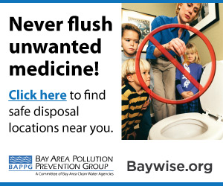

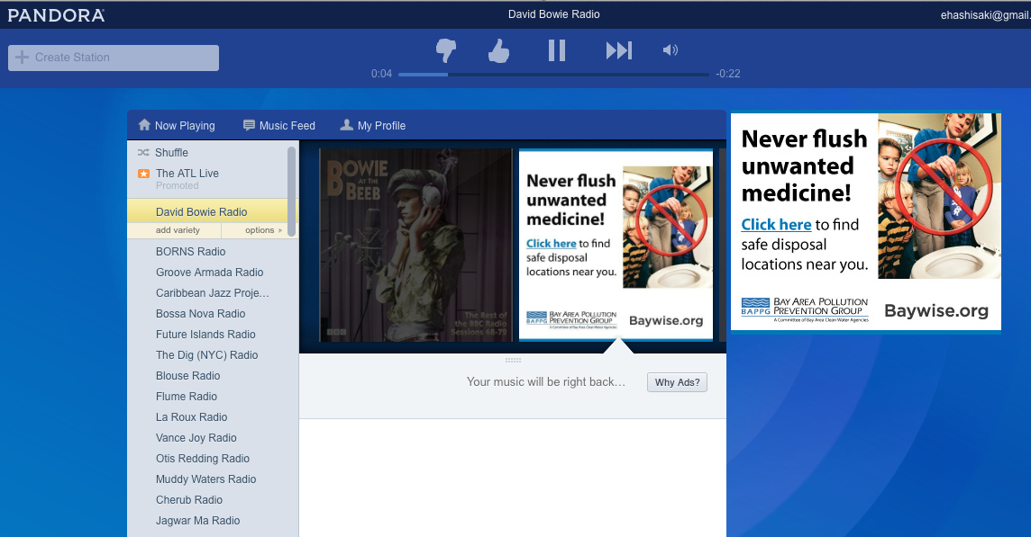
Facebook and Pandora online ads

8. Pollutant: Triclosan

Pollutant Description
Triclosan is found in various consumer products and has been linked to a range of adverse health and environmental effects. Though currently an unregulated pollutant, member agencies recognize that effective triclosan outreach may help residents recognize other constituents of emerging concern such as microbeads, and be more accepting to regulatory changes.

Key Messages
- Targeted towards mothers and primary household purchasers

Project | Description | Timeline | Budget
Dental Assistant / Hygienist Outreach | Stephanie Hughes includes insights on triclosan during pharmaceutical and dental waste disposal discussions. | January-June 2016 | N/A*
*Included above with mercury and pharmaceuticals

Results
- Reached 237 dental trainees and instructors (per Mercury section)

Project | Description | Timeline | Budget
Personal Care Product Outreach | O’Rorke developed and ran Facebook and Pandora online ads to educate residents about the negative impacts of Triclosan. | April – May 2016 | $3,000

Results
Facebook Online Ads
- Ran 10/26/15 – 11/15/15
- 514,118 impressions
- 7,372 clicks, 1.4% CTR

Next Steps
BAPPG will develop social marketing campaign and tailored collateral targeting outreach toward specific products and consumer groups.

Materials
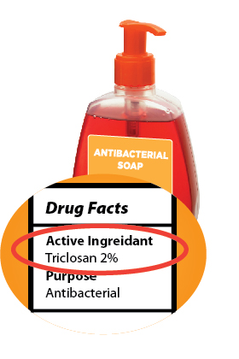
Images used for Facebook Ads

9. Pollutant: Trash and Wipes

Pollutant Description
Trash is a top priority due to the improper disposal of non-woven wipes and other non-flushable trash items such as hair, ear swabs and all products claiming to be biodegradable or flushable. Most consumer wipes products (labeled flushable or not) take much more time to disperse in water than toilet paper, which has caused issues for many POTWs in the Bay Area, including damage to pumping station equipment, grinders and other infrastructure, stoppages, and sanitary sewer overflows. Wipes and other nondispersibles are also a safety issue for pump station employees that have suffered needle sticks from “deragging” pumps clogged with wipes.

Key Messages
- Wipes Clog Pipes!
- Toilets Aren’t Trashcans

Project | Description | Timeline | Budget
Dental Assistant/ Hygienist Outreach | As part of the dental waste discussion, speaker includes insights about microbeads and “flushable” wipes. This audience is very receptive to all BAPPG messages. More than 95% female, they are typically the primary purchaser for their families, and as medical professionals, are concerned about health and water quality. | January-June 2016 | N/A*
*Included above with mercury

Results
- Reached 237 dental trainees and instructors (same audience reached as “Mercury” results above)

Project | Description | Timeline | Budget
Toilets Aren’t Trashcans | O’Rorke developed and submitted an article to parenting magazines and developed a poster on multi-pollutants for parents groups. | January – June 2016 | $3,000

Results
- Pitched article to local parenting publications
- Covered by the Berkeley Parents Network

Materials
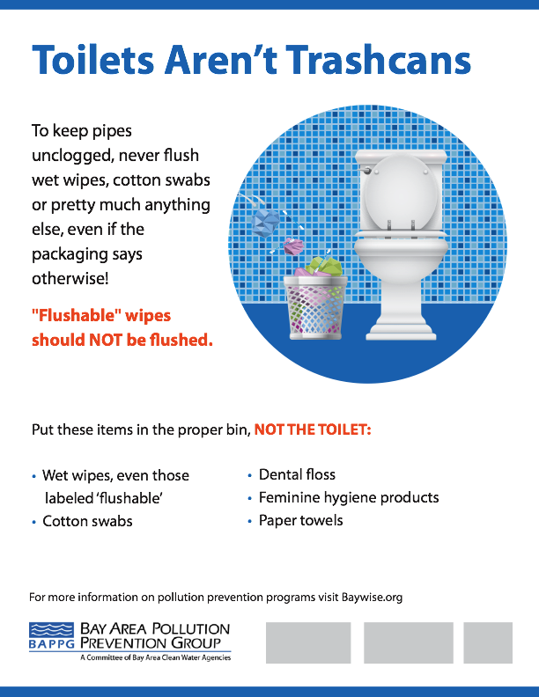
Toilets Aren’t Trashcans poster for parent groups

Project | Description | Timeline | Budget
Toilet’s Aren’t Trashcans | O’Rorke developed mobile and print ads designed for BAPPG’s placements with Chinook Book | January – June 2016 | $3,000

Materials
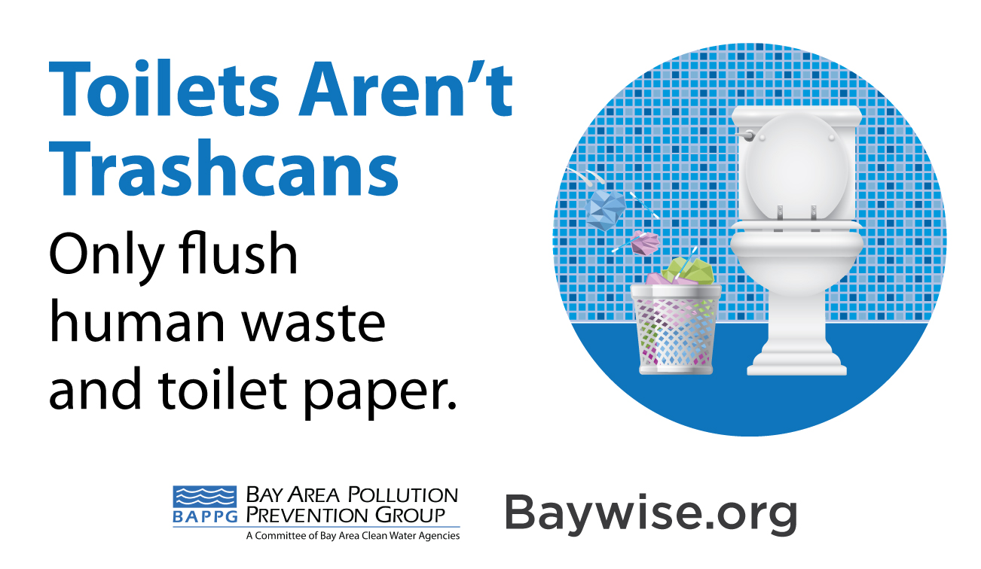
Toilets Aren’t Trashcans Mobile Chinook Book Ad

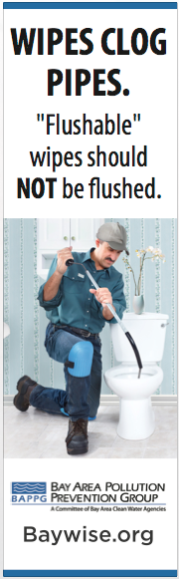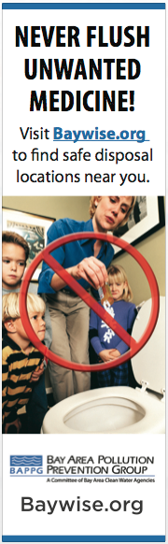
Toilets Aren’t Trashcans Print Chinook Book Ad

Next Steps
BAPPG will continue to include messages about trash and wipes when meeting with medical, hospice, and dental professionals and trainees. BAPPG will also distribute collateral during professional presentations and regional outreach events and continue outreach campaigns in conjunction with National P2 Week to continue stressing “Wipes Clog Pipes!” message.

Next Meeting Date: 10/05/2016

Next Report to be Delivered: Mid-January 2017

