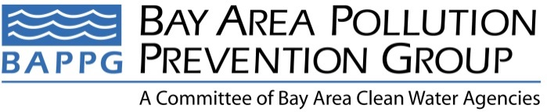

2017 Annual Report
Covering reporting period of 1/1/17 – 12/31/17

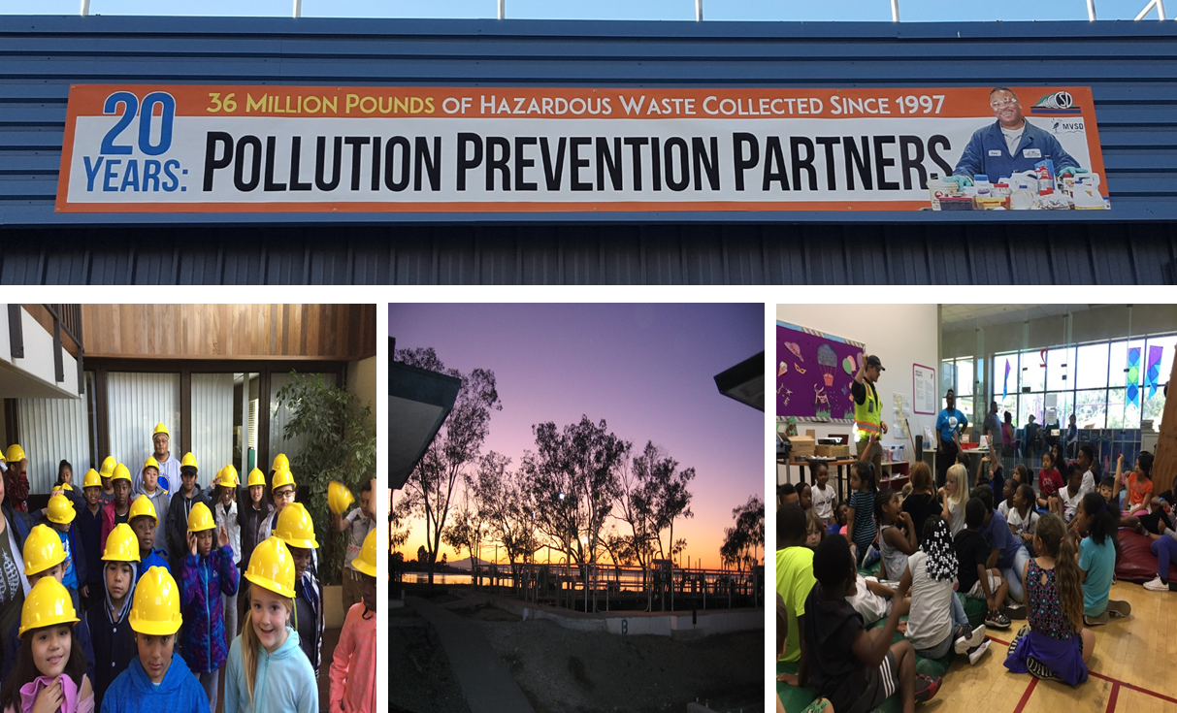

BAPPG Chair: Doug Dattawalker  BAPPG Co-Chair: Debbie Phan  BAPPG Vice Chairs: Joanne Le and Simret Yigzaw | Prepared by: Joanne Le  Submitted to: Bay Area Clean Water Agencies  Date: 01/16/2018

2017 Annual Report
January1, 2017 – December 31, 2017

Executive summary

The Bay Area Pollution Prevention Group (BAPPG), a subcommittee of Bay Area Clean Water Agencies (BACWA), is comprised of 43 Bay Area wastewater agencies that work together to coordinate pollution prevention activities and leverage resources for smaller agencies to reduce the amount of toxic pollutants discharged into the San Francisco Bay and local waterways. Wastewater agency representatives meet monthly to share information, leverage resources, and develop regional activities that help member agencies meet regulatory outreach requirements and BAPPG goals.

2017 Committee Updates

All files pertaining to BAPPG are now being added to the BACWA BAPPG webpage. This includes meeting agendas, meeting minutes, reports, presentations, and information on pollutants of concern.

2017-2018 BAPPG officers were selected:
- Chair – Doug Dattawalker, Union Sanitary District
- Co-Chair – Debbie Phan, Regional Water Quality Control Board
- Co-Vice Chair – Joanne Le, City of Richmond
- Co-Vice Chair – Simret Yigzaw, City of San Jose

CURRENT PROJECT UPDATES

This report serves as an update to BACWA and member agencies for all BAPPG projects, by pollutant, which took place from January 1, 2017, through December 31, 2017.
- Copper
- Fats Oils and grease (FOG)
- Mercury and Silver
- Pesticides
- Pharmaceuticals
- Triclosan
- Trash and Wipes

1. Pollutant: Copper

Pollutant Description
Copper pipe corrosion has been a major concern to the wastewater community for more than a decade. For many years, the messages have focused on proper installation, including the use of a water-based flushable flux. In California, there are also alternatives to copper pipe for potable and non-potable installations, such as PEX. Further, copper is a pesticide used in swimming pools and spas and incorporated into fabrics.

Key Messages
- Select only ASTM B813 water-flushable flux rather than petroleum-based flux (which is not flushable and increases pipe corrosion rates).
- Incorporate additional BMPs during design, reaming, cleaning, and building commissioning that will reduce pipe corrosion rate.
- Seek mitigation options for copper products that are used in swimming pools, spas, and fountain treatments (often drained to sanitary sewer) as well as copper-treated fabrics that are subsequently laundered.

Project | Description | Timeline | Budget
Outreach to Plumbers, Apprentices, and Building Inspectors | Be available to provide presentations to plumbing unions and building inspector associations about plumbing installation BMPs. | Calendar Year 2017 | $500
EPA Review of Copper Based Pesticides | Review and comment upon EPA registration reviews | October 2016 | Prior FY

Results
- Supported one presentation at Laney Community College, Oakland (15 students) about our flux and flushing BMPs.
- During the public comment period for the U.S. EPA Copper Registration Review risk assessment in 2016, it was asked that U.S. EPA require users to contact local agencies and follow their instructions for draining copper-treated swimming pools, spas, and fountains to avoid copper pollution and collection system backup. EPA agreed and in 2017, it proposed such instructions be placed on all swimming pool and spa products. (Our stormwater agency partners are currently asking for this to be extended to fountain products too.) Although EPA was also asked to examine discharges from washing treated fabrics, it declined to do so, saying that it has insufficient data to support a detailed assessment, and that it guessed that fabrics are unlikely to be a large wastewater copper discharge source. Based on these outcomes, did not provide comments on EPA’s 2017 proposed copper pesticides review decision.

Next Steps
BAPPG has been delivering the copper plumbing BMP messages for more than a decade, yet BAPPG learned in 2013 that the “best practice” of selecting water-flushable flux (“Key Message #1, and consistent with the Universal Plumbing Code standard) is being virtually ignored throughout the plumbing sector. In addition, in 2014 Stephanie Hughes completed an analysis of copper versus PEX from life cycle and worker safety perspectives that included information to support the use of PEX installations. These findings initiated discussions within BAPPG regarding whether to update plumbing messages.

Prior to continuing or developing outreach actions, it may be appropriate to update the copper source analysis for wastewater. The copper source analysis often cited within BAPPG is a 1996 document incorporating an assumption from a 1994 document. At the August 2015 IAPMO meeting, participants questioned the date of the analysis and suggested that there may be new or different sources at this time.

2. Pollutant: Fats, Oils and Grease (FOG)

Pollutant Description
FOG is a top priority due to the associated regulatory and financial impacts to member agencies. FOG is a major problem for sewer systems, causing sewer back-ups, sewer overflows onto streets, and foul sewer odors. Because of this, cities often spend millions of dollars a year responding to grease-related sewer blockages and in infrastructure improvements.

Key Messages
- Don’t pour grease down the drain – collect and recycle used cooking oil.

Project | Description | Timeline | Budget
Spanish Holiday Outreach | Through Univision Hispanic Radio, KBRG 100.3 FM, BAPPG promoted messages of proper grease disposal to the South Bay, East Bay, and North Bay. Outreach included:  - Three weeks of radio spots on KBRG  - Calls-to-action to visit Baywise.org | November 20 – 26 and December 18 – 31, 2017 | $7,000*
*Cost excludes the cost of online streaming radio spots, which were not streamed due to Univision’s mistake. Instead, O’Rorke will work with Univision to run these spots and other make good parameters in the Spring of 2018 targeting Toilets are not Trash Cans campaign.

Results
- 91 :30 Spanish radio spots
- 28 :15 BONUS Spanish radio spots
- 119 total campaign spots

Next Steps
In addition to continuing BAPPG’s FOG campaign with Univision, BAPPG plans to host a joint BAPPG / BACWA Pretreatment Committee meeting to present on mobile food trucks and discuss opportunities surrounding regional best management practice (BMP) and collateral development.

3. Pollutant: Mercury and Silver

Pollutant Description
Outreach regarding best management practices for dental amalgam and silver fixer waste is essential to ensure member agencies continue to meet regulatory standards and prevent pollution of receiving waters.

Key Messages
- Dental amalgam and silver fixer wastes are hazardous and shall not be disposed in dental office sinks.
- Incorporate BMPs for dental amalgam, silver fixer, and other hazardous wastes within a dental office.
- The mandated use of BMPs and amalgam separators has significantly decreased the mercury loads into the sewer.
- As of July 2017, the US EPA is mandating the installation of amalgam separators and the use of several key BMPs.

Project | Description | Timeline | Budget
Dental Assistant/ Hygienist Outreach | Stephanie Hughes served as a guest speaker in dental assistant / hygienist classes in local colleges throughout the Bay Area. | Calendar Year 2017 | $4,000

Results
Reached a total of 150 students and instructors from January 1, 2017 – December 31, 2017 at the following site visits:
- San Jose City College (one class)
- College of Marin, Novato (one class)
- Foothill College, Los Altos (two classes)
- Mt Diablo Adult Ed, Concord (three classes)

The annual presentation at Santa Rosa Jr. College (which typically reaches 48-50 students) was canceled due to the fall fires that closed the school for two weeks, reducing the time available for instructors to complete their course.

Next Steps
Continue to provide the guest speaker to local colleges. The instructors have come to rely on these annual visits and have incorporated BAPPG’s program into their instructional calendar. Further, this is a very relevant audience for other messages, such as wipes, microbeads, and triclosan. BAPPG will be updating the Baywise.org documents for line flushing chemicals to better align with EPA regulations.

4. Pollutant: Pesticides

Pollutant Description
Improper indoor and outdoor application of pesticides can result in chemical runoff into the sewer systems and receiving waters, leading to lower pollutant removal efficiencies at treatment plants, potential biosolids management limitations, as well as aquatic ecosystem degradation.

Key Messages
- Promote integrated pest management and less-toxic products as alternatives to pesticides
- Seek alternatives to fipronil and other topical (collar and spot-on) pet treatments (conducted alternative analysis and currently drafting messages)

Project | Description | Timeline | Budget
OWOW | Our Water Our World (OWOW) is a Bay Area-wide outreach program that promotes the use of less-toxic pest control methods and products in the home and garden through local retailers. | Calendar Year 2017 | $10,000

Results
- Continued the makeover of the look and content of the Our Water, Our World materials from the previous fiscal year with relatively minor content changes to the Pest or Pal Activity Guide for Kids and an alternative shelf tag that uses the word “effective” rather than “less-toxic” for use on select products, particularly fertilizers.
- Coordinated program implementation with major chains Home Depot, Orchard
Supply Hardware (OSH), and Ace Hardware National. Corporate office of OSH
(San Jose) and Home Depot (Atlanta) directed support of the program with their
stores.
- Maintained an inventory of the following: fact sheets, shelf tags, literature rack
display signage, 10 Most Wanted brochures, Pest or Pal Activity Guide for Kids,
custom-designed product guide dispensers, and three versions of product guides
(OSH, Home Depot, and generic), from which participating agencies could
purchase materials.
- Updated less-toxic Product Lists: 4 versions – generic product-by-pesticide-fertilizer,
generic product-by-pest, OSH product-by-pest, and Home Depot product-by-pest.
- Conducted employee trainings and tabling events at Our Water, Our World stores.
- Compiled information and provided outreach specific to current issues:
- Mosquito control and the Zika virus.
- Asian Citrus Psyllid and Huanglongbing bacterium.
- Maintained Our Water, Our World website.
- Provided Ask-the-Expert service—which provides 24-hour turnaround on answers to
pest management questions.
- Provided and staffed exhibitor booths and made presentations to attendees.
- NorCal trade show, San Mateo (February 2017).
- Provided on-call assistance (e.g., display set-up, training, IPM materials review) to
specific stores (e.g., OSH, Home Depot).
- Participated in UCIPM Continuing Education for IPM Advocates.
Although effectiveness information need only be provided in the 2019 annual reports
(C.9.g), below are some outputs and outcomes for FY 16-17:
- 124 Our Water, Our World store trainings.
- 1,017 employees trained at Our Water, Our World stores.
- 107 tabling events at Our Water, Our World stores.
- 6,577 customers contacted by Advocates at tabling events at stores.
- Increases over last year in trainings by 11%, trainees by 16%, and customers
reached at tablings by 30%.
- Home Depot reported that Scott’s Miracle Gro increased the sales of their less
toxic pesticide product line Nature’s Care by 49%.

Project | Description | Timeline | Budget
Flea & Tick Talking Points | Evaluate flea products with regards to pathways to sewers. Develop and communicate recommendations for pet owners and veterinarians to reduce impact to sewers. | Calendar Year 2017 | $3,000

Results
- Continued the development of outreach messages regarding alternatives to fipronil and other topical pet treatments.
- Continued a dialogue regarding fipronil and alternative flea management strategies with the California Veterinary Medical Association.
- Drafted a strategy to initiate dialogue with Bay Area veterinary professional groups in 2018.
- Communicated with the California Department of Pesticide Regulation (DPR) and the San Francisco Estuary Institute (SFEI) to understand the latest insights regarding transport to sewer and fipronil toxicity.

Project | Description | Timeline | Budget
Regulatory Tracking and Communications | Identify pesticide regulatory actions at federal and state level. Communicate with regulators to ensure that wastewater issues are included in the analyses. | Calendar Year 2017 | $30,000

Results
- Coordinated with BAPPG to update the list of highest priorities pesticides for BACWA’s attention. Created an updated pesticides watch list for tracking purposes.
- Provided a “crystal ball” schedule of anticipated pesticide regulatory activities on these pesticides. Prepared a detailed tracking spreadsheet for EPA activities, with docket numbers and EPA contact emails, and a near-term priorities tracking summary, updated monthly or bimonthly.
- Tracked pesticide-related regulatory activities by EPA and DPR and new scientific information that have significant potential to affect BACWA member agencies. Notified BAPPG of such items as they arose. On the basis of regulatory documents, relevant scientific information, and the regulatory context, made recommendations regarding regulatory participation or other follow-up steps on multiple EPA and DPR actions relating to pesticides including copper, pyrethroids, imidacloprid, several swimming pool chemicals, and root control chemicals. When so directed, provided key points for comments and reviewed draft comment letters by BACWA and its allies.
- Supported preparation the following BACWA letters to EPA on pesticides:
  - Pyrethroids – comments on EPA’s risk assessment and recommendations for EPA’s consideration in development of risk mitigation. This letter focused on shortcomings in EPA’s POTW modeling, including EPA’s omission of on-pet flea/tick treatments and options for risk mitigation for pet treatments, impregnated fabrics, discharges from lice and scabies treatments, and bifenthrin-specific measures due to its persistence. A second letter with the same themes addressed the pyrethroid Flumethrin, which had a different comment period.
  - Imidacloprid – comments on EPA’s risk assessment and recommendations for EPA’s consideration in development of risk mitigation. This letter focused on EPA’s omission of on-pet flea/tick treatments and options for risk mitigation for pet treatments.
  - Indoxacarb – comments on EPA’s risk assessment and recommendations for EPA’s consideration in development of risk mitigation. This letter focused on EPA’s omission of on-pet flea/tick treatments and options for risk mitigation for pet treatments.
  - Swimming pool chemicals – proposed decisions on Boric Acids & Salts (BACWA) and Hypchlorites (NACWA only). These letters continued BACWA’s work to ensure that EPA requires applicable products to carry new swimming pool, spa, and fountain product label language to direct owners to contact their local sanitation agency prior to discharging treated water.
  - Diquat dibromide – comments on EPA’s proposed Registration Review decision, focusing on revisions to EPA’s proposed instruction for pre-application POTW notification.
  - Dichlobenil – comments on EPA’s risk assessment and recommendations for EPA’s consideration in development of risk mitigation. This letter focused on scientific errors in EPA’s POTW discharge modeling, omission of collection system workers from the health risk assessment, and a request that EPA require pre-application POTW notification.
  - EPA Pesticides regulatory reform – in a response to EPA’s request for input on reducing regulatory burden, commented on changes that EPA could make in its pesticides regulatory program to reduce pesticide-related burdens on POTWs while maintaining environmental protections. Suggestions included improving EPA pesticide scientific review procedures addressing POTW discharges, eliminating the “treated article exemption” from pesticide regulation (which allows treated fabrics and similar products to be sold without EPA scientific analysis or state controls), and removing barriers to availability of POTW-related pesticide scientific and regulatory information.
Coordinated with and provided technical support for NACWA and Water Board, which also sent letters on almost all of these items:
- Coordinated City of Palo Alto and Water Board emailed requests to DPR responding to DPR’s public notice on receipt of the registration application for the first copper/silver drinking water treatment product, requesting that DPR’s Surface Water Protection Program carefully evaluate implications of the copper and silver discharges from this potential product.
- Based on existing open lines of communication with pesticide regulators, pesticide manufacturers, and scientists researching pesticides in wastewater, notified BAPPG of important information obtained through these contacts.
- Provided technical information to support BACWA’s coordination with NACWA on Federal pollution prevention topics, including pesticides and Toxic Substances Control Act (TSCA) reform.
- Tracked TSCA reform implementation, reviewed draft regulations on chemical prioritization and risk assessments from POTW perspective, and provided key points and other technical support for BACWA’s coordination with NACWA on providing comments on these two regulations. Analyzed outcome of final regulations and developed and worked with NACWA to implement science-focused strategy toward improving integration of POTW discharges into the EPA TSCA review process.
- Coordinated and provided scientific support for communications with EPA and DPR about wastewater pesticides discharges, wastewater pesticides monitoring, and improving wastewater pesticides predictive modeling to support registration decisions. Arranged multiple teleconference meetings with EPA and DPR to discuss wastewater modeling and monitoring. Continued semi-annual informal information-sharing teleconference meetings between BACWA’s pesticide workgroup and DPR’s wastewater experts.
- Continued scientific and management conversations with both EPA and DPR around the new scientific evidence linking pet flea control treatments and fipronil and imidacloprid in POTW effluent, and changing EPA standard procedures that currently ignore the contribution of these products to wastewater.
- Continued follow-up up work to ensure that EPA requires applicable products to carry new swimming pool, spa, and fountain product label language to direct owners to contact their local sanitation agency prior to discharging treated water.
- Prepared and gave presentation on pet flea control product transport to wastewater effluent “San Francisco Bay area wastewater monitoring reveals previously unidentified pathway for pet spot-on flea treatments to reach estuaries” in an SFEI-organized session, “Contaminants in Urban & Coastal Estuarine Ecosystems” at the 2017 Spring American Chemical Society meeting in San Francisco in April. Participated in this and other pesticides/wastewater sessions.
- Evaluated outcomes of BACWA input to EPA and DPR and briefed BAPPG/BACWA pesticides leads on these outcomes to assess effectiveness of BACWA’s work.
- Developed an agenda and materials for a monthly BACWA Pesticides Workgroup teleconference meeting to determine appropriate actions and to coordinate actions with NACWA and San Francisco Bay Regional Water Board staff. Provided staff support during the meetings and an action item list after each meeting.

Next Steps
BAPPG plans to continue funding OWOW to conduct regional IPM and less-toxic product outreach and education. BAPPG will continue working with Dr. Kelly Moran to track opportunities to comment on pesticide registration and evaluation activities by U.S. EPA and the California Department of Pesticide Regulation, with consideration of water quality impacts via the POTW pathway. BAPPG will continue to work with O’Rorke and Stephanie Hughes to develop a regional pitch to accompany the anticipated California Department of Pesticide Regulation findings on the toxicity of fipronil in flea and tick treatment products using the newly developed talking points. BAPPG will coordinate such messages and materials with the OWOW campaign and with veterinary professionals.

Materials

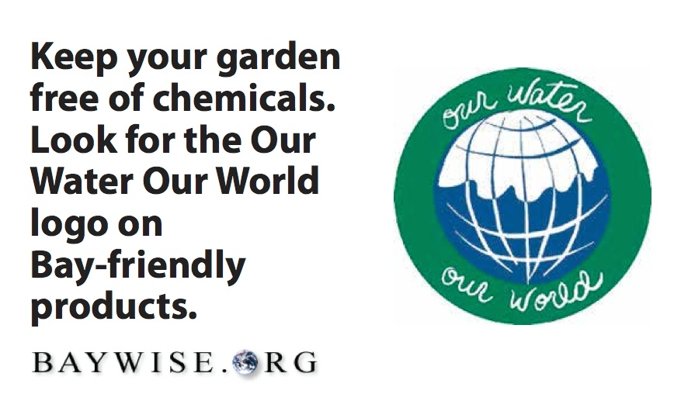
Chinook Book mobile ads

5. Pollutant: Pharmaceuticals

Pollutant Description
Pharmaceuticals can enter water resources and the San Francisco Bay through improper disposal into wastewater streams (e.g., flushing pharmaceuticals down the toilet). Pharmaceuticals have endocrine disrupting properties, and unintended exposure of pharmaceuticals to aquatic life and humans can lead to adverse health effects. Outreach surrounding safe disposal of pharmaceuticals is essential to ensure member agencies meet regulatory standards and prevent pollution of receiving waters. There is potential to combine water quality messaging with broader messaging surrounding health and safety to target wider audiences while still ensuring that safe disposal is the key take-away.

Key Messages
- No Drugs Down the Drain
- Don’t Rush to Flush – Meds in the Bin, We All Win!
- Prevent Accidental Poisoning, Drug Abuse and Water Pollution by disposing medicines properly
Project | Description | Timeline | Budget
Dental Assistant/ Hygienist Outreach | Insights about proper pharmaceutical disposal included as part of dental waste discussion. | Calendar Year 2017 | N/A*
*Included above with mercury

Results
Reached 150 dental trainees and instructors (per Mercury section)

6. Pollutant: Triclosan

Pollutant Description
Triclosan is found in various consumer products and has been linked to a range of adverse health and environmental effects. Although the US Food and Drug Association (FDA) has now banned triclosan from hand soaps (effective September 2017), triclosan is allowed in numerous other consumer products.

Key Messages
- Targeted towards mothers and primary household purchasers

Project | Description | Timeline | Budget
Dental Assistant / Hygienist Outreach | Stephanie Hughes includes insights on triclosan during pharmaceutical and dental waste disposal discussions. | Calendar Year 2017 | N/A*
*Included above with mercury and pharmaceuticals
Results
- Reached 150 dental trainees and instructors (per Mercury section)

7. Pollutant: Trash and Wipes

Pollutant Description
Trash is a top priority due to the improper disposal of non-woven wipes and other non-flushable trash items such as hair, ear swabs and all products claiming to be biodegradable or flushable. Most consumer wipes products (labeled flushable or not) take much more time to disperse in water than toilet paper, which has caused issues for many POTWs in the Bay Area, including damage to pumping station equipment, grinders and other infrastructure, stoppages, and sanitary sewer overflows. Wipes and other non-dispersibles are also a safety issue for pump station employees that have suffered needle sticks from “deragging” pumps clogged with wipes.

Key Messages
- Wipes Clog Pipes!
- Toilets Aren’t Trashcans

Project | Description | Timeline | Budget
Dental Assistant/ Hygienist Outreach | As part of the dental waste discussion, speaker includes insights about microbeads and “flushable” wipes. This audience is very receptive to all BAPPG messages. More than 95% female, they are typically the primary purchaser for their families, and as medical professionals are concerned about health and water quality. | Calendar Year 2017 | N/A*
*Included above with mercury

Results
- Reached 150 dental trainees and instructors (same audience reached as “Mercury” results above)

Project | Description | Timeline | Budget
Toilet’s Aren’t Trashcans | O’Rorke ran a regional online advertising campaign to educate residents about the importance of never flushing wipes down the Toilet.  - Facebook ads | June 9 – 23, 2017 | $974
Results
- 167,492 impressions
- 242 clicks
- .14% CTR
- 184 visits to Baywise.org
Materials

Image from Toilets Aren’t Trashcans Facebook Ads

Project | Description | Timeline | Budget
Wipes outreach during P2 week | O’Rorke implemented a regional online and mobile advertising campaign to educate residents about the importance of never flushing wipes. The campaign coincided with P2 week in September, and ads will run again in the Spring to coincide with Earth Day activities. O’Rorke utilized online ad artwork developed by CCCSD in 2016.  - Division D Online and Mobile ads  - Facebook ads | September 11 – 24, 2016 | $2,700

Results
Division D online and mobile ads  - 1,114,105 impressions  - 1,814 clicks  - .16% CTR | Facebook ads  - 304,252 impressions  - 540 clicks  - .18% CTR
- There were 2,381 visits to Baywise.org during the month of September, with 90% of those visits occurring between September 18 - 24
- For comparison, the site received only 285 visits during the previous month

Materials

Online ads from CCCSD
Next Steps
BAPPG will continue to include messages about trash and wipes when meeting with medical, hospice, and dental professionals and trainees. BAPPG will also distribute collateral during professional presentations and regional outreach events and continue outreach campaigns in conjunction with National P2 Week to continue stressing “Wipes Clog Pipes!” message. BAPPG will run additional “Wipes Clog Pipes” online and mobile ads with Facebook and Division D in April of 2018 to coincide with Earth Day.

